Table of Contents:

User Stories

2 – Introductory Notes

3 – Website Login

4 – Website Logout

5 – Database Revision History

6 – Adding Drugs to the database

10 – Editing Drugs in the database

13 – Removing/Restoring Drugs in the database

14 – Updated the mobile app

15 – Adding Enzymes/Interactions to the database

19 – Editing Enzymes/Interactions in the database

22 – Adding new users to the website

25 – Editing existing users

27 – Remove/Restore users

28 – Offline usage

29 – Drug Names

30 – Alphabetical sorting

31 – Switching name sort in mobile

32 – Risk icons and sorting

33 – Viewing Drugs

36 – Viewing Enzymes

39 – Interaction Types

40 – Filters on mobile App

41 – Navigation

42 – “About” Information

43 – Viewing Dose Adjustments

46 – Website Account Settings

48 – Booting up the App

49 – Removed Features

Supplementary Tests

50 – List of included Behat Tests

52 – PHP Unit Tests for Website

53 – Database and API Tests

54 – HTML/JS tests

Testing notes:

**It is assumed that the user running these tests has an understanding of what each data field means when filling our Medical forms

54.201.147.95 is the temporary web address for our site. This is subject to change after the end of this course.

In addition to this document we have several tests in our system:

-Behat Tests

-PHP Unit Tests for the Website

-Database testing

-API Testing

-HTML/JS testing

Template:

***Story ID:***

***Github ID numbers:***

***Title: 1)***

***Overview:***

***Steps:***

***Failure:***

***Limitations:***

Story ID: 1

Github ID numbers: #87, #123

Title: 1) I want to securely log into the website

Overview:

A basic UI login that follows standard login conventions

Steps:

1. 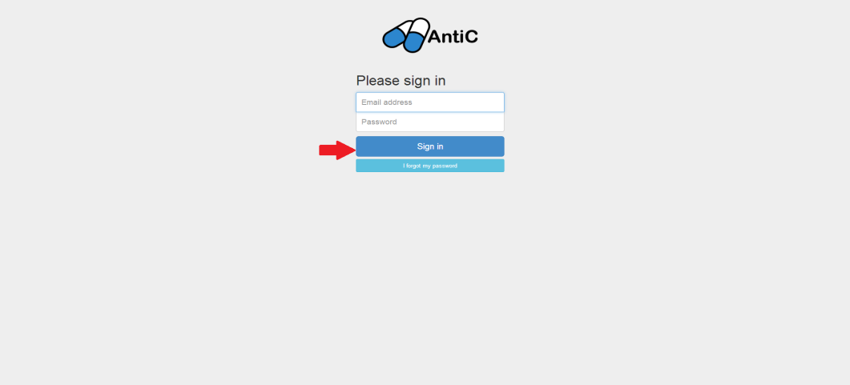Given I am on "http://54.201.147.95/console/login"
2. Fill in "Username" with "admin@antic.com"
3. Fill in "Password" with "admin"
4. Press "Sign In"
5. Then the URL should match " http://54.201.147.95/console"

Exceptions: (Noted by “Bad Credentials” or “Please Fill Out This Field” appearing)

-Incorrect Password or Username

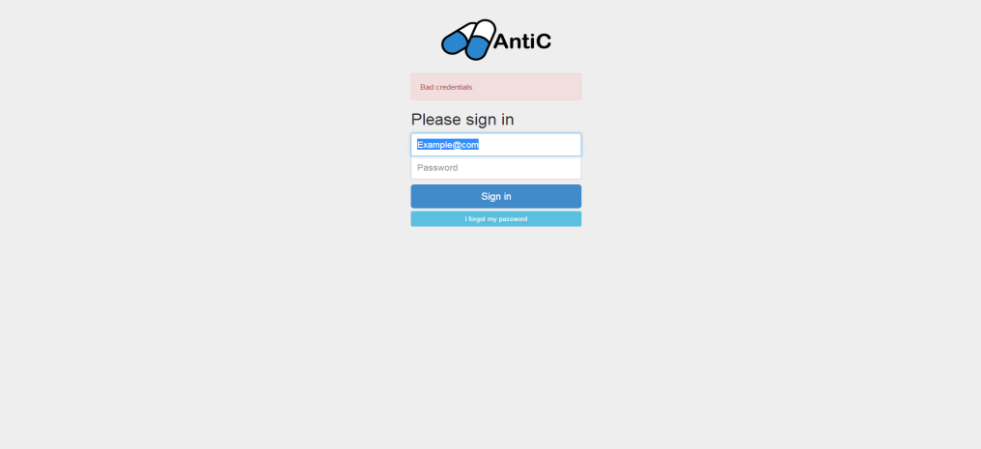 -Blank Password or Username

Limitations:

-The above login credentials are for testing. Replace them with your login credentials.

Story ID: 2

Github ID numbers: #87, #123

Title: 1) I want to log out at the end of a session

Overview:

A button to log out from the server to maintain privacy

Steps:

1. Login (Story ID #1)
2. Let user do whatever activities they would like to in the session
3. 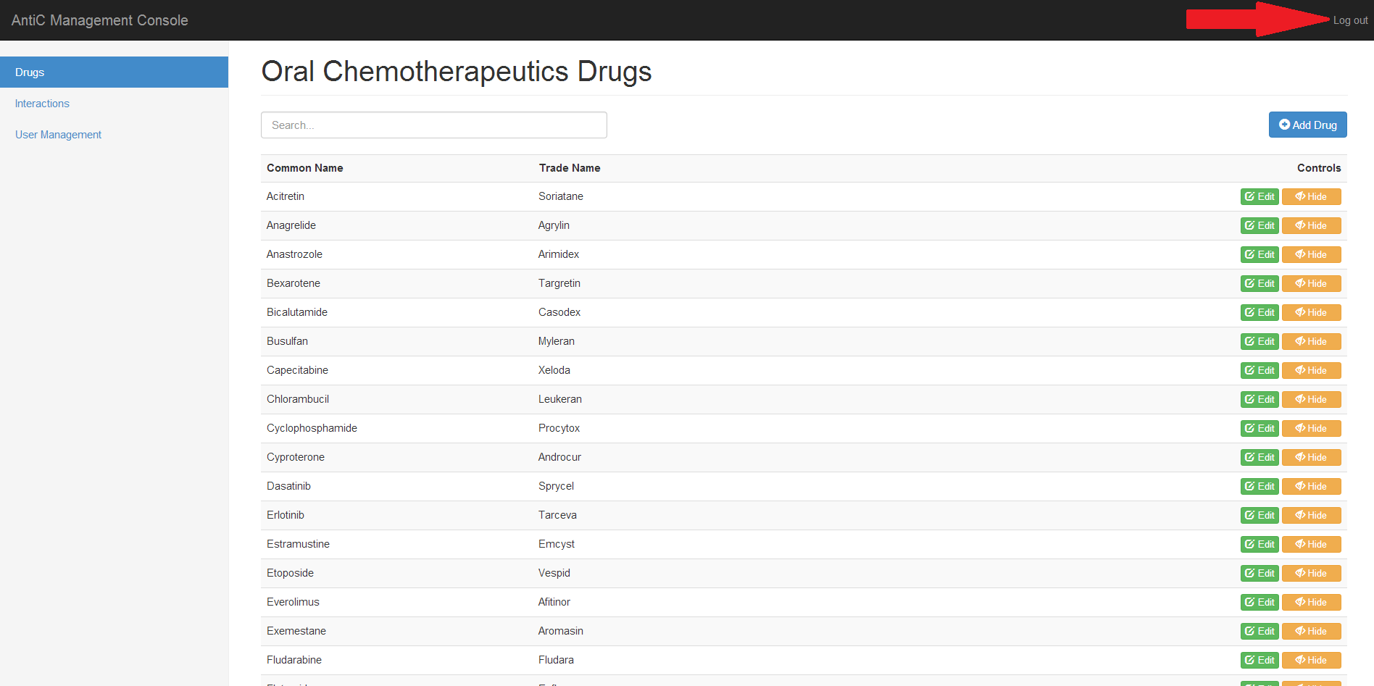From any page, press “Logout”.

Exceptions:

N/A

Limitations:

Redirecting yourself away from the site or back to the login screen will automatically close your session, so you will not be able to log out since the server automatically did that for you.

Story ID: 3

Github ID numbers: #302, #303

Title: 1) I want to keep track of when updates are made, and who made them

Overview:

Automated revision data stored to monitor data change. The user does not need to do any work themselves; the website will take care of it for you.

Steps:

1. The website automatically adds the account name and date to edits on the following pages:
   1. New Drugs (Story ID #4)
   2. Edit Drugs (Story ID #5)
   3. New Interactions/Enzymes (Story ID #8)
   4. Edit Interactions/Enzymes (Story ID #9)
2. Who updated the website last will be shown on the Edit Drug/Interactions page

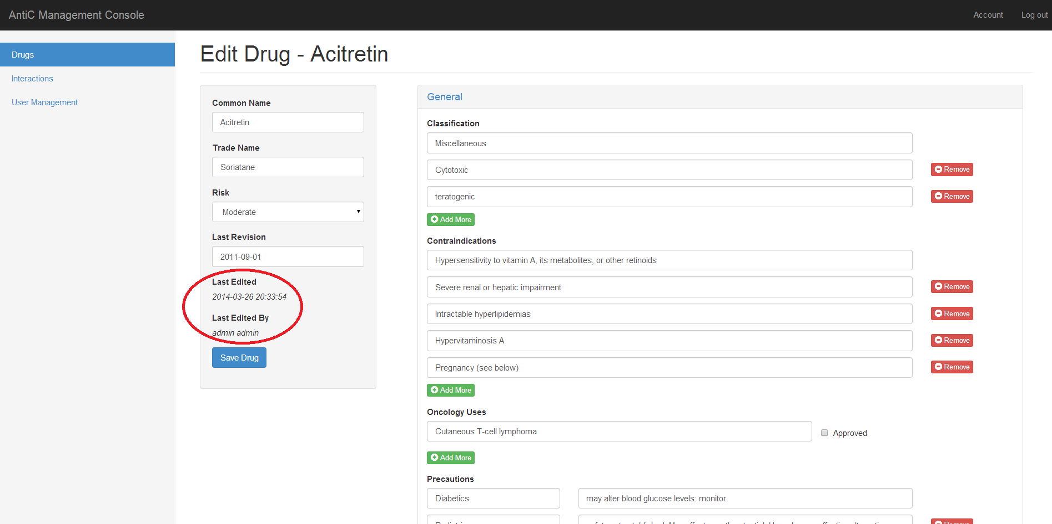

Exceptions:

N/A

Limitations:

The initial data pushed directly to the database has a default name of “direct input”

Data pushed from sources other than the website will have the name “Web API”

Story ID: 4

Github ID numbers: #1, #5, #89, #125

Title: 1) I want to add new drugs to the database when I press "save" on the databases web page for additions

Title: 2) I want to add new drugs to the website

Title: 3) I want to add new Dose Adjustments into the database via the website

Title: 4) I want to add new Dose Adjustments into the website

Overview:

The form for submitting properly formatted drug information pages.

Steps:

1. Login (Story ID #1)
2. 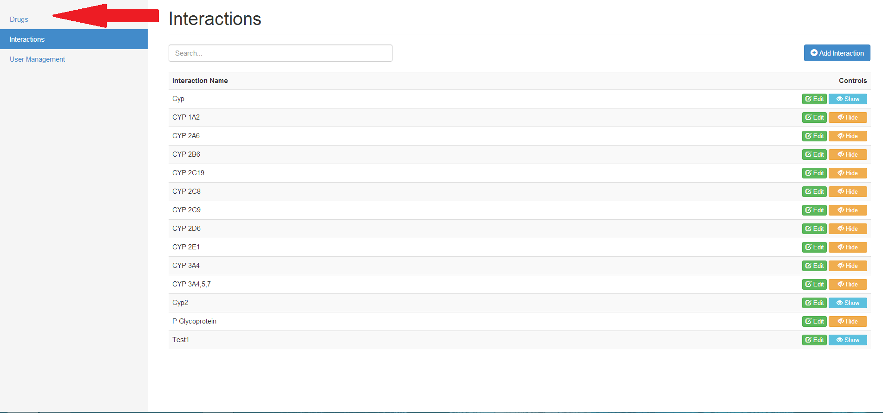Press “Drugs” if not on Drug Page
3. Press “Add Drug”

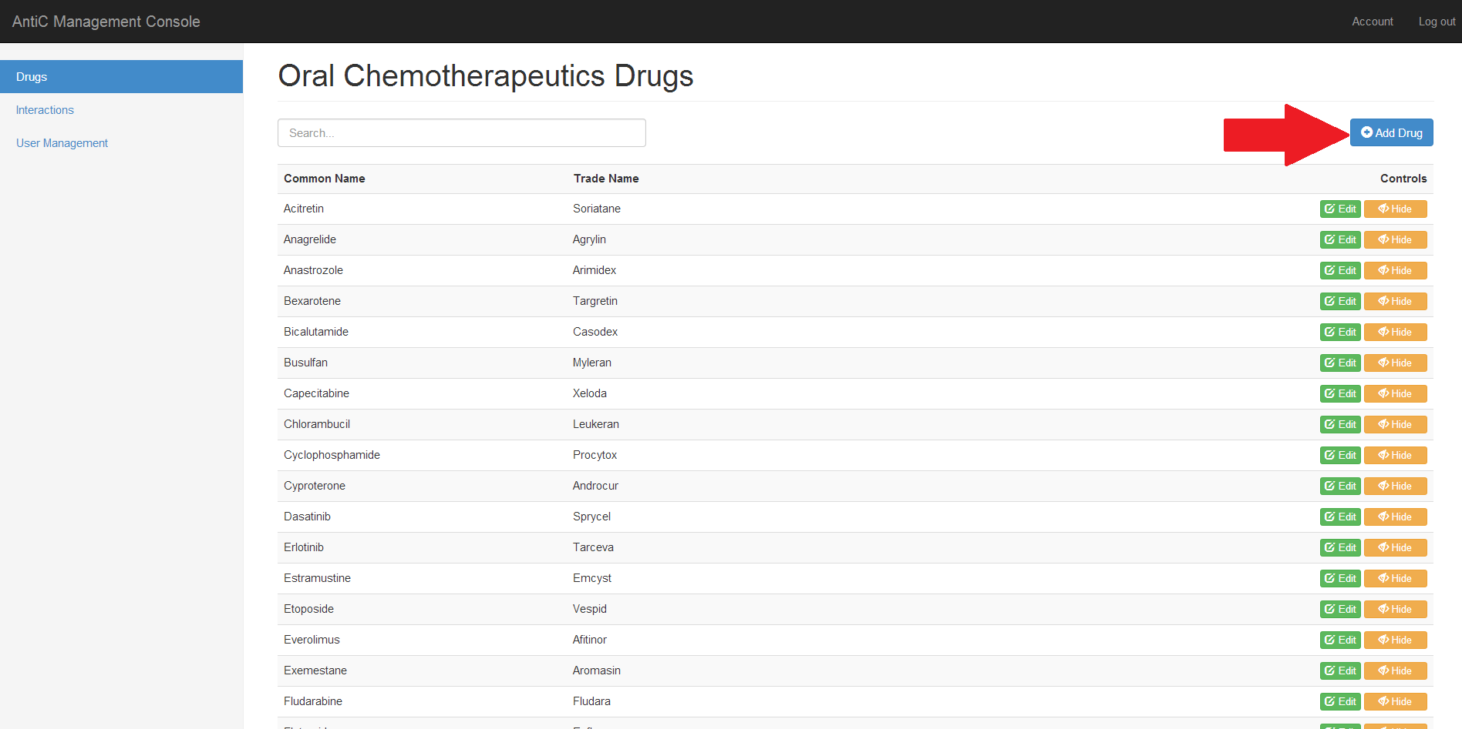

Story ID: 4

1. The URL should match "/console/drugs/add"

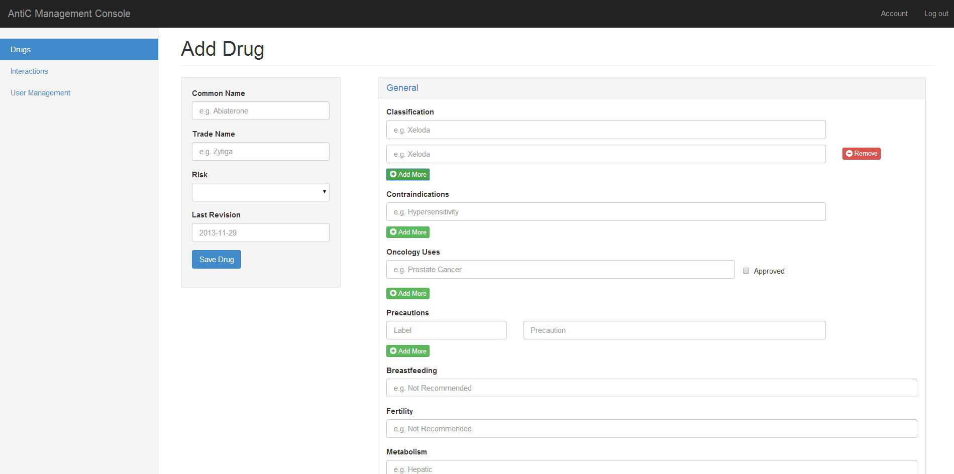

1. fill in "Common Name " with "<Insert Desired Name>"
2. fill in "Risk" with "<Insert Desired Risk Level>"
3. Fill in other data fields as appropriate to that specific drug
4. For some fields, a green “add” button is available to add additional fields, or a red “remove” button to remove unused fields. Dose Adjustments are a subcategory of drugs.

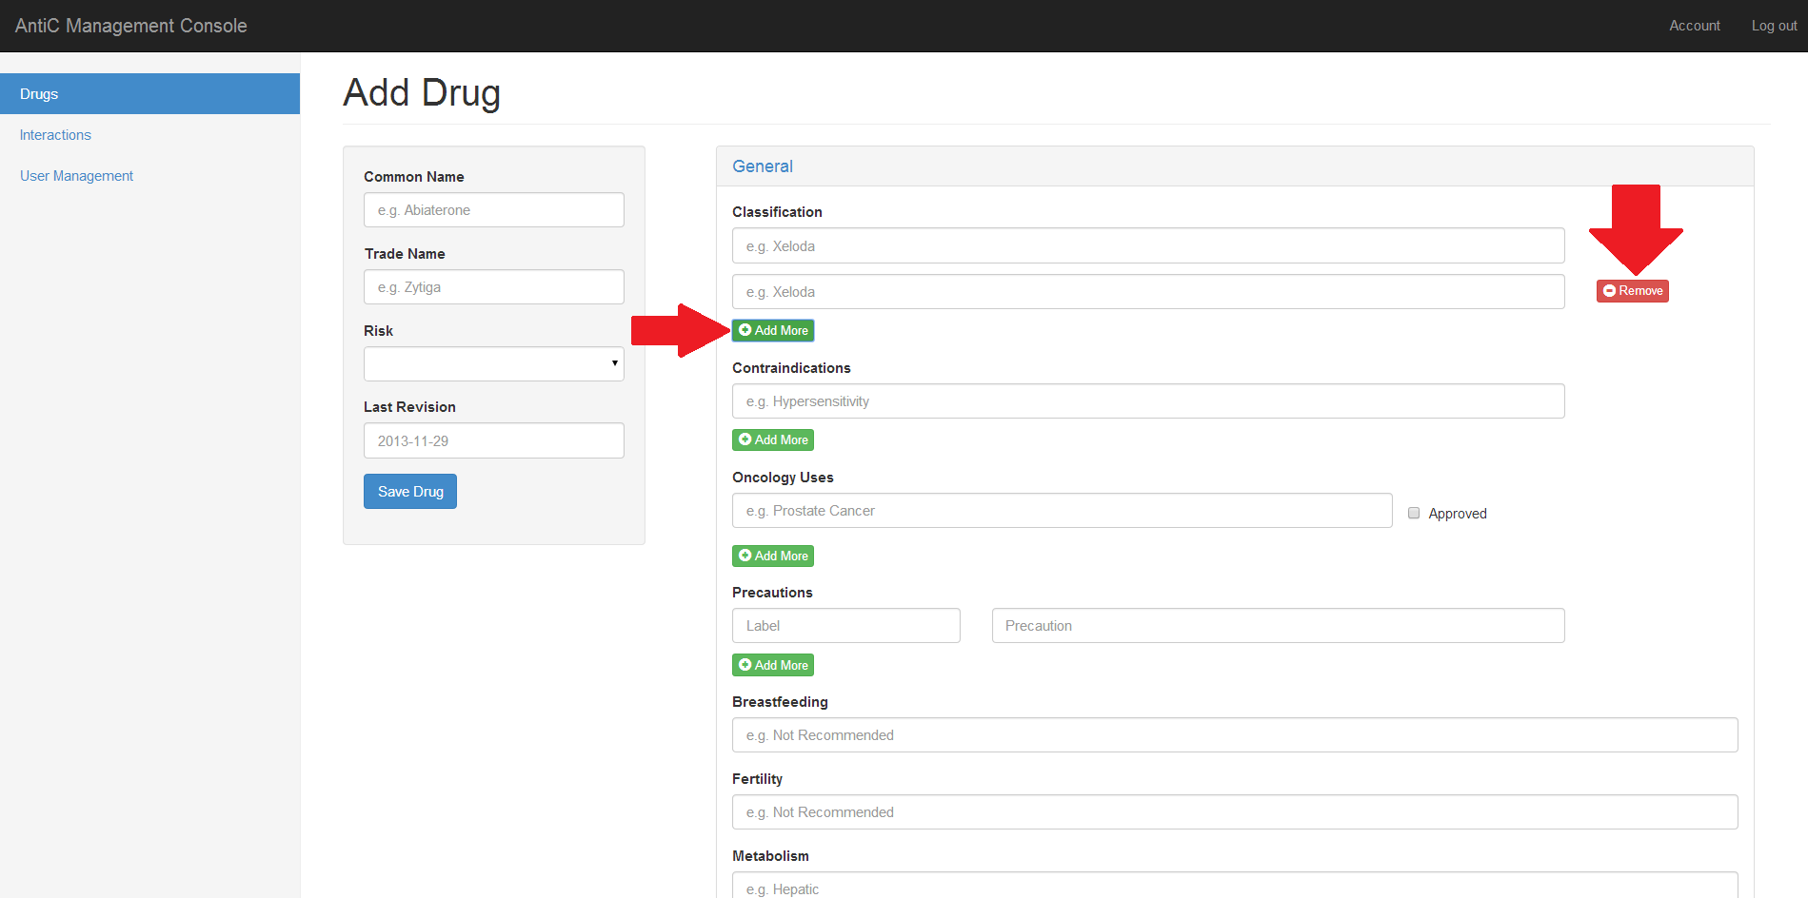

Story ID: 4

1. For Dose adjustments, you have the option to upload a file, so if you wish to upload one make sure you know where it is on your computer.

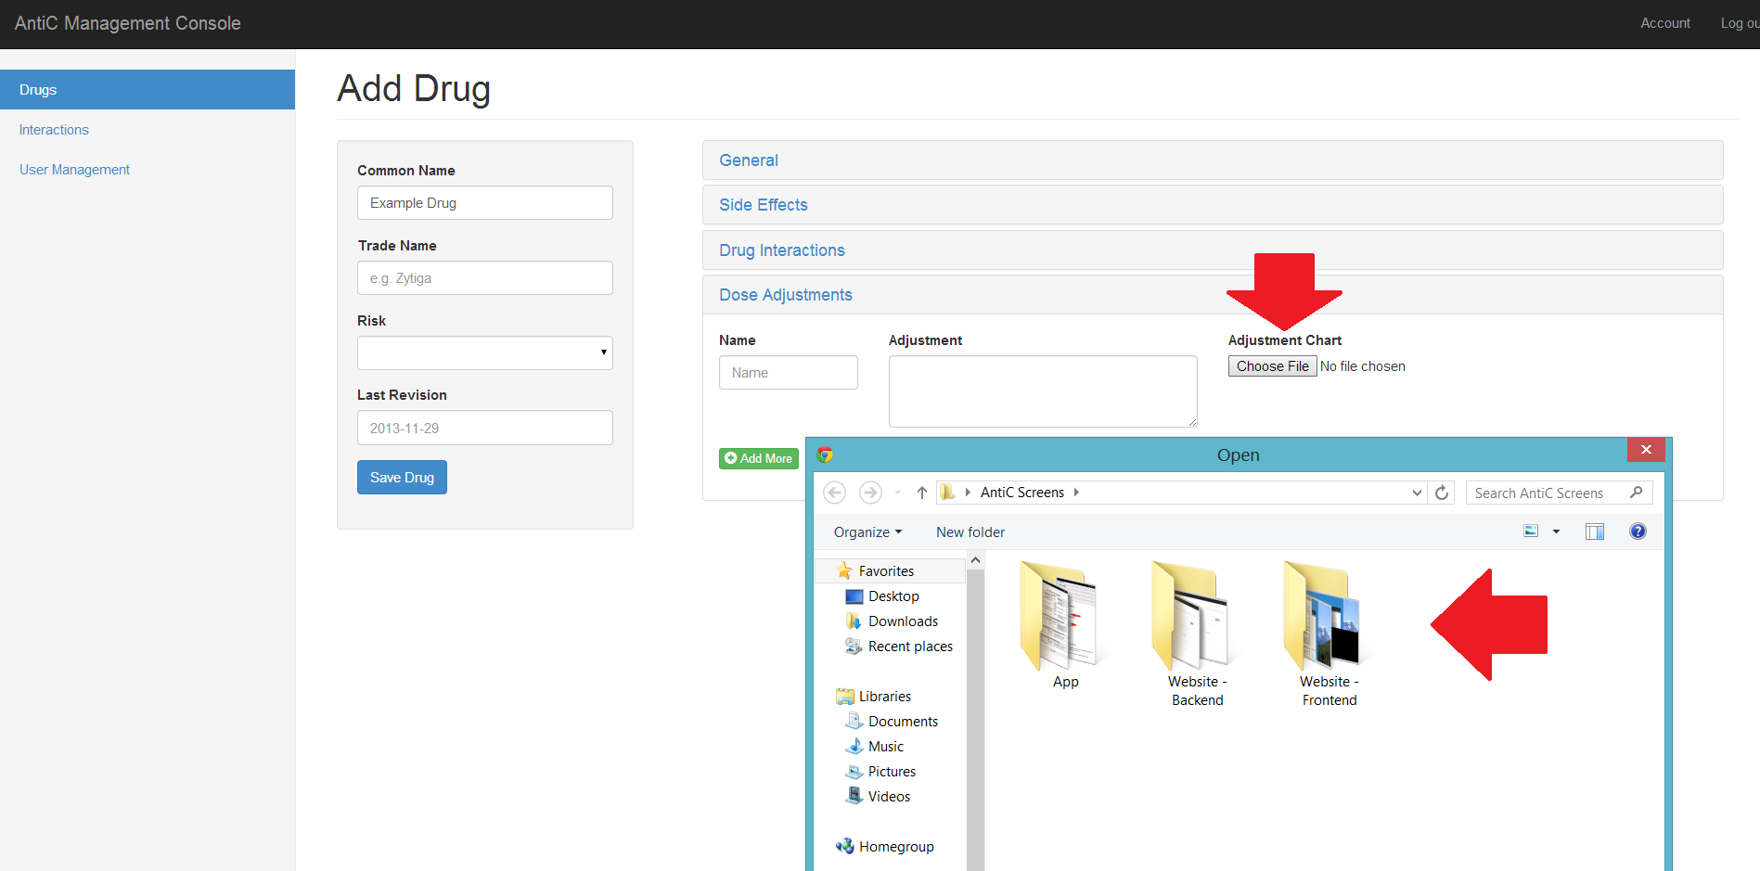

1. 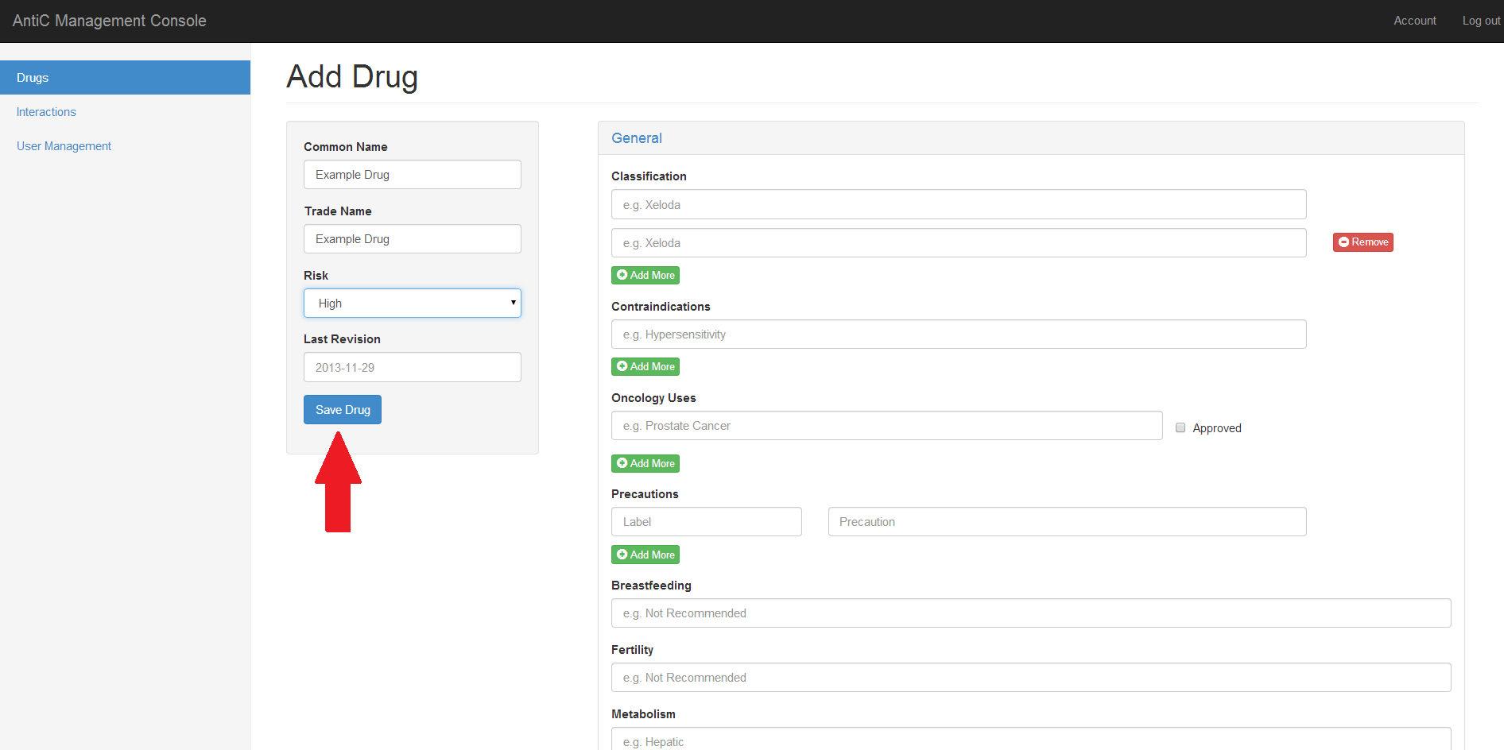press "Save Drug"

Story ID: 4

Exceptions:

Empty Common Name

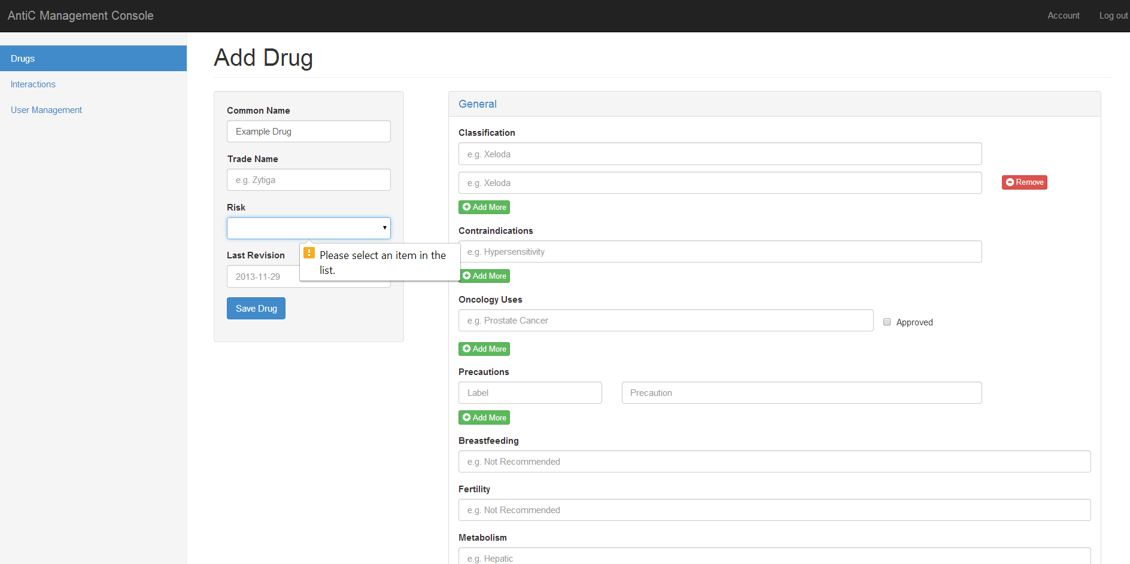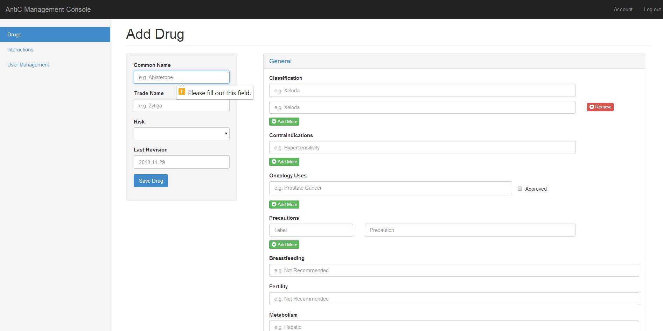Empty Risk

Limitations:

Only required fields (as specified by client) are “Risk” and “Common Name”

Common Name/Trade Name limited at 60 characters

Other fields limited at 255 characters

Story ID: 5

Github ID numbers: #2, #5

Title: 1) I want to alter drugs that are already present in database

Title: 2) I want to alter drugs that are already present in website

Overview:

Once a drug has already been placed on the site, this page mimics the “Add” page, but populates it with the drug of your choice.

For some fields, a green “add” button is available to add additional fields, or a red “remove” button to remove unused fields.

Steps:

1. Login (Story ID #1)
2. Press “Drugs” if not on Drug Page
3. Click the “Edit” button on the row of my desired drug

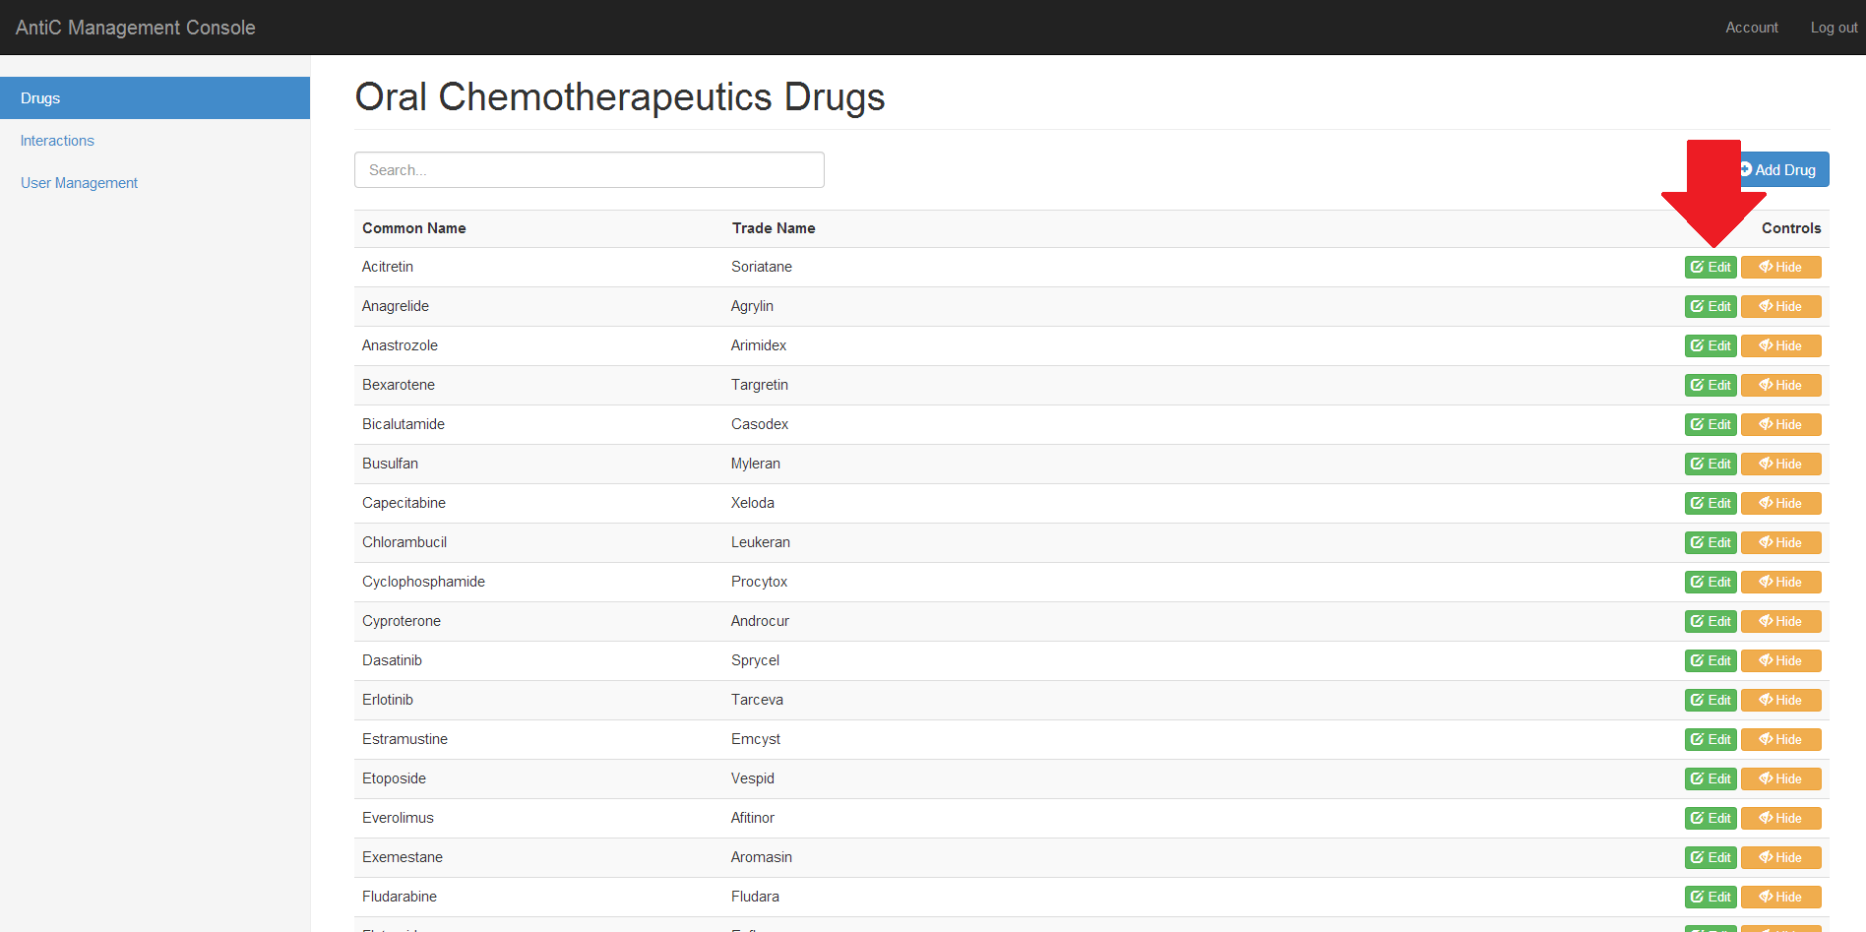

Story ID: 5

1. The URL should match "/console/drugs/<selected drug>"
2. 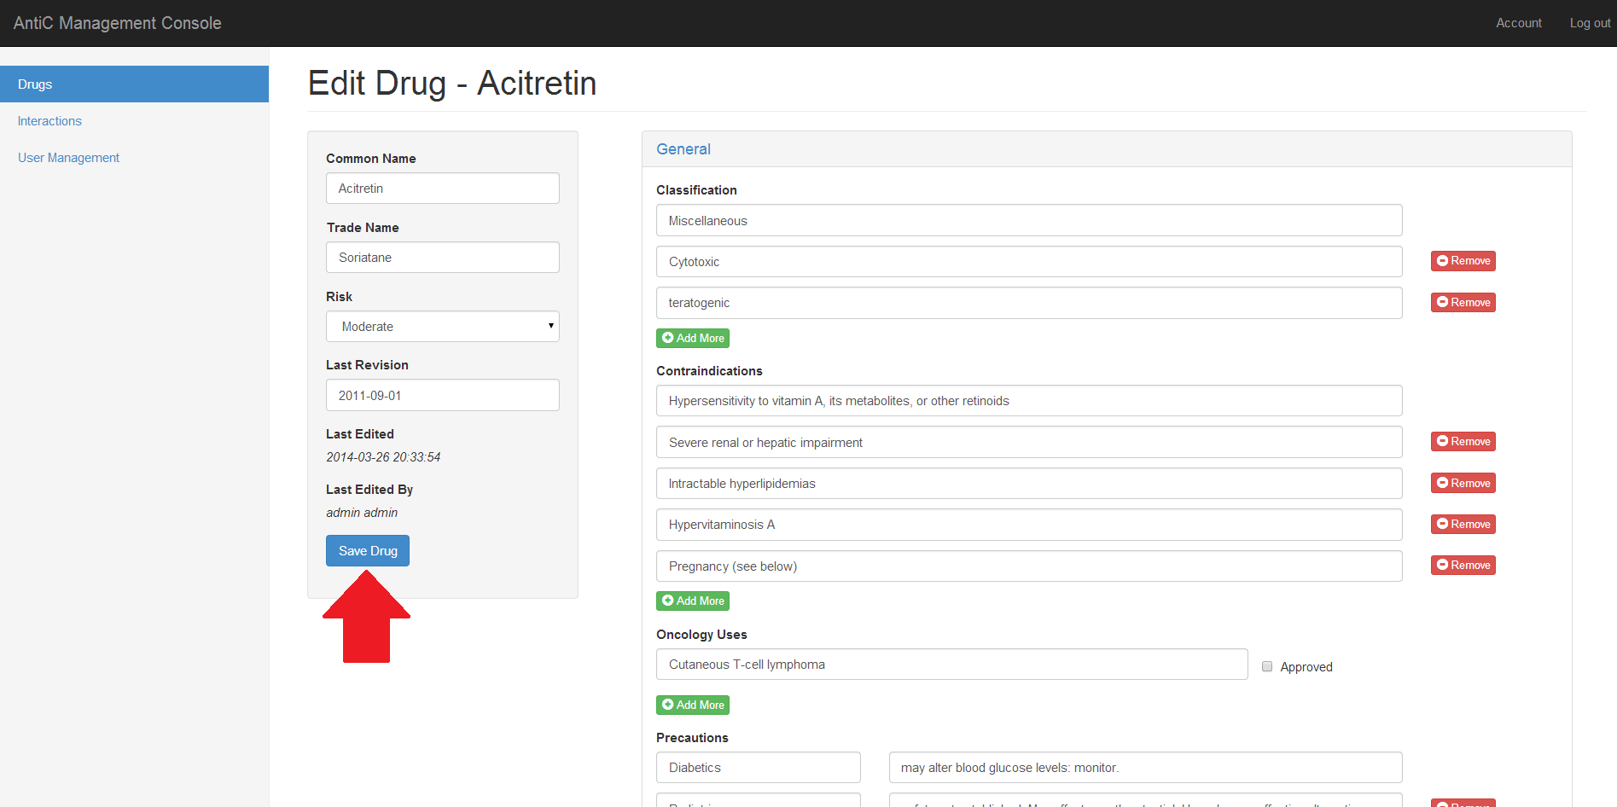Edit fields as necessary
3. **When done,** press "Save Drug"

Exceptions:

Empty Common Name



Story ID: 5

Empty Risk

Limitations:

Only required fields (as specified by client) are “Risk” and “Common Name”

Common Name/Trade Name limited at 60 characters

Other fields limited at 255 characters

Story ID: 6

Github ID numbers: #3, #5

Title: 1) I want to be able to remove/restore drugs from the database

Title: 2) I want to be able to remove/restore drugs from the website

Title: 3) I want to be able to remove/restore dose adjustments from the database

Title: 4) I want to be able to remove/restore dose adjustments from the website

Overview:

When the user wants a drug to no longer be visible in the public app/ webview, he can disabled it with the “Hide” button. Since medical data is time consuming to enter and may be needed again later, we were directed to hide the info rather than remove it entirely. Dose adjustments are a subcategory of drugs.

Steps:

1. Login (Story ID #1)
2. Press “Drugs” if not on Drug Page



1. Change the state using the button on the row of the drug you desire to hide/show
   1. Press the orange “Hide” button to make invisible
   2. Press the blue “Show” button to make visible

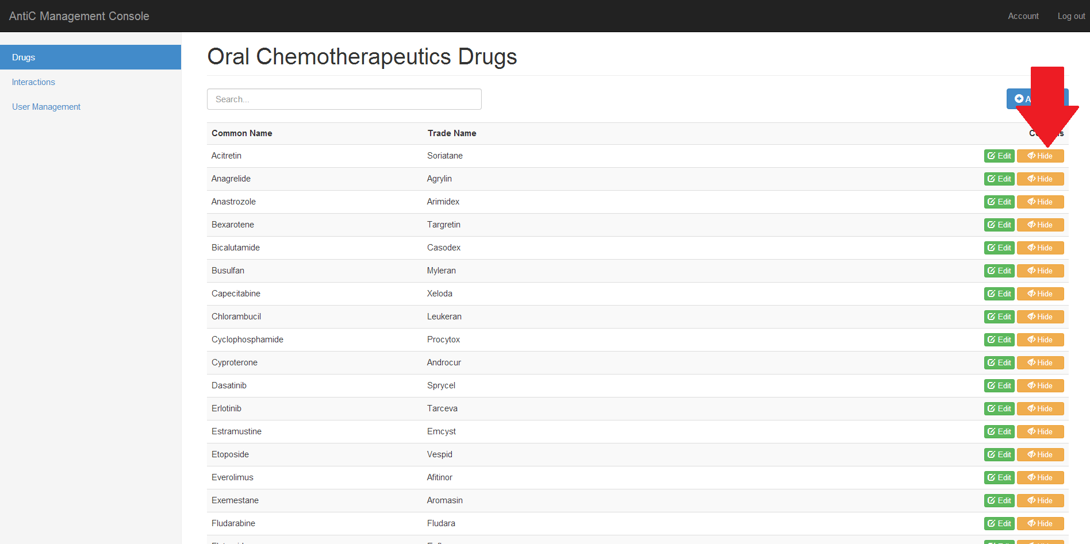

Story ID: 7

Github ID numbers: #4, #15, #58

Title: 1) I want my modified website to be updated on my users app

Title: 2) I want my modified database to be updated on my users app

Title: 3) I want to be prompted to download updates when I do access a wireless network

Title: 4) I want the app to look for new updates on startup

Overview:

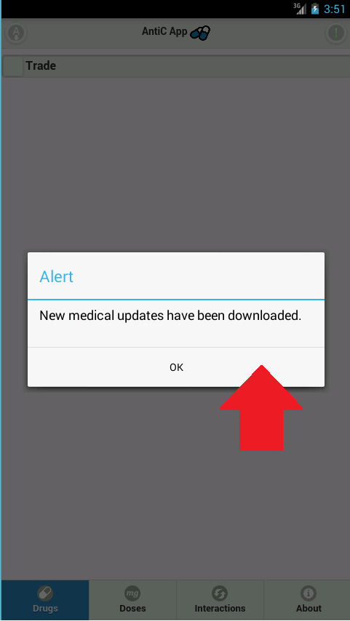When the mobile app is first installed, and when it connected to WiFi or a cellular network, it will prompt the user to update the content library, which will be pulled from the server and stored on your Android or iOS device.

Steps:

First time use only:

1. Install the app via the provided link or app store download

All users:

1. Boot up the “AntiC App” (Story ID#26)
2. Upon loading, the user will be prompted to install the new data
3. Upon clicking “Okay”, the local database will be updated.

Failure:

This will only work in a WiFi or Cellular Connection

Limitations:

As described above, this will only work in a WiFi or Cellular Connected device.

Story ID: 8

Github ID numbers: #129

Title: 1) I want to add new Enzymes into the website

Title: 2) I want to add new Interactions into the website

Title: 3) I want to add new Enzymes into the database via the website

Title: 4) I want to add new Interactions into the database via the website

Overview:

The form for submitting properly formatted interaction and enzyme information pages.

For some fields, a green “add” button is available to add additional fields, or a red “remove” button to remove unused fields.

Steps:

1. Login (Story ID #1)
2. Press “Interactions” if not on Interactions Page

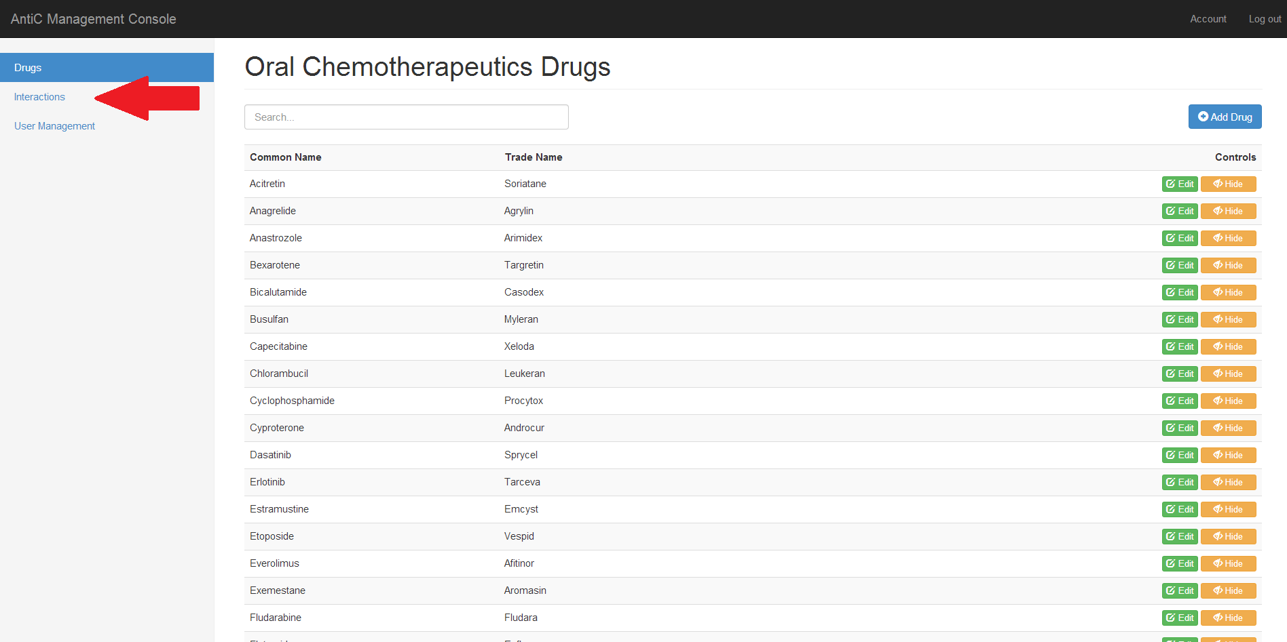

Story ID: 8

1. Press “Add Interaction”

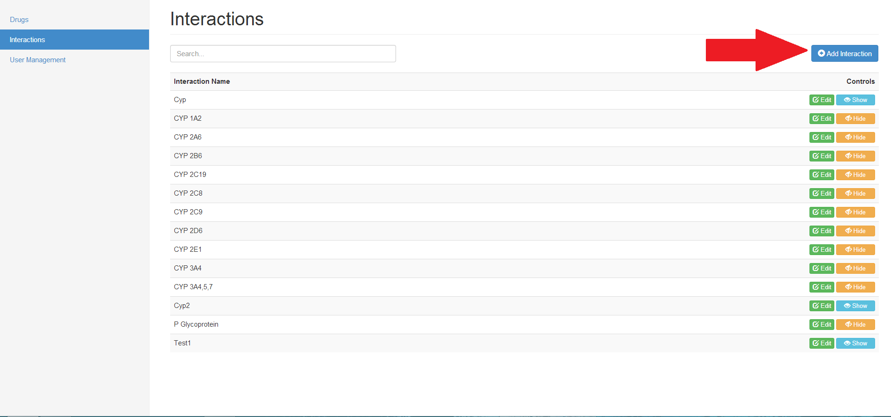

1. The URL should match "/console/interactions/add"
2. fill in "Enzyme Name " with "<Insert Desired Name>"
3. Fill in interactions as appropriate to that specific enzyme
4. For some fields, a green “add” button is available to add additional fields, or a red “remove” button to remove unused fields.

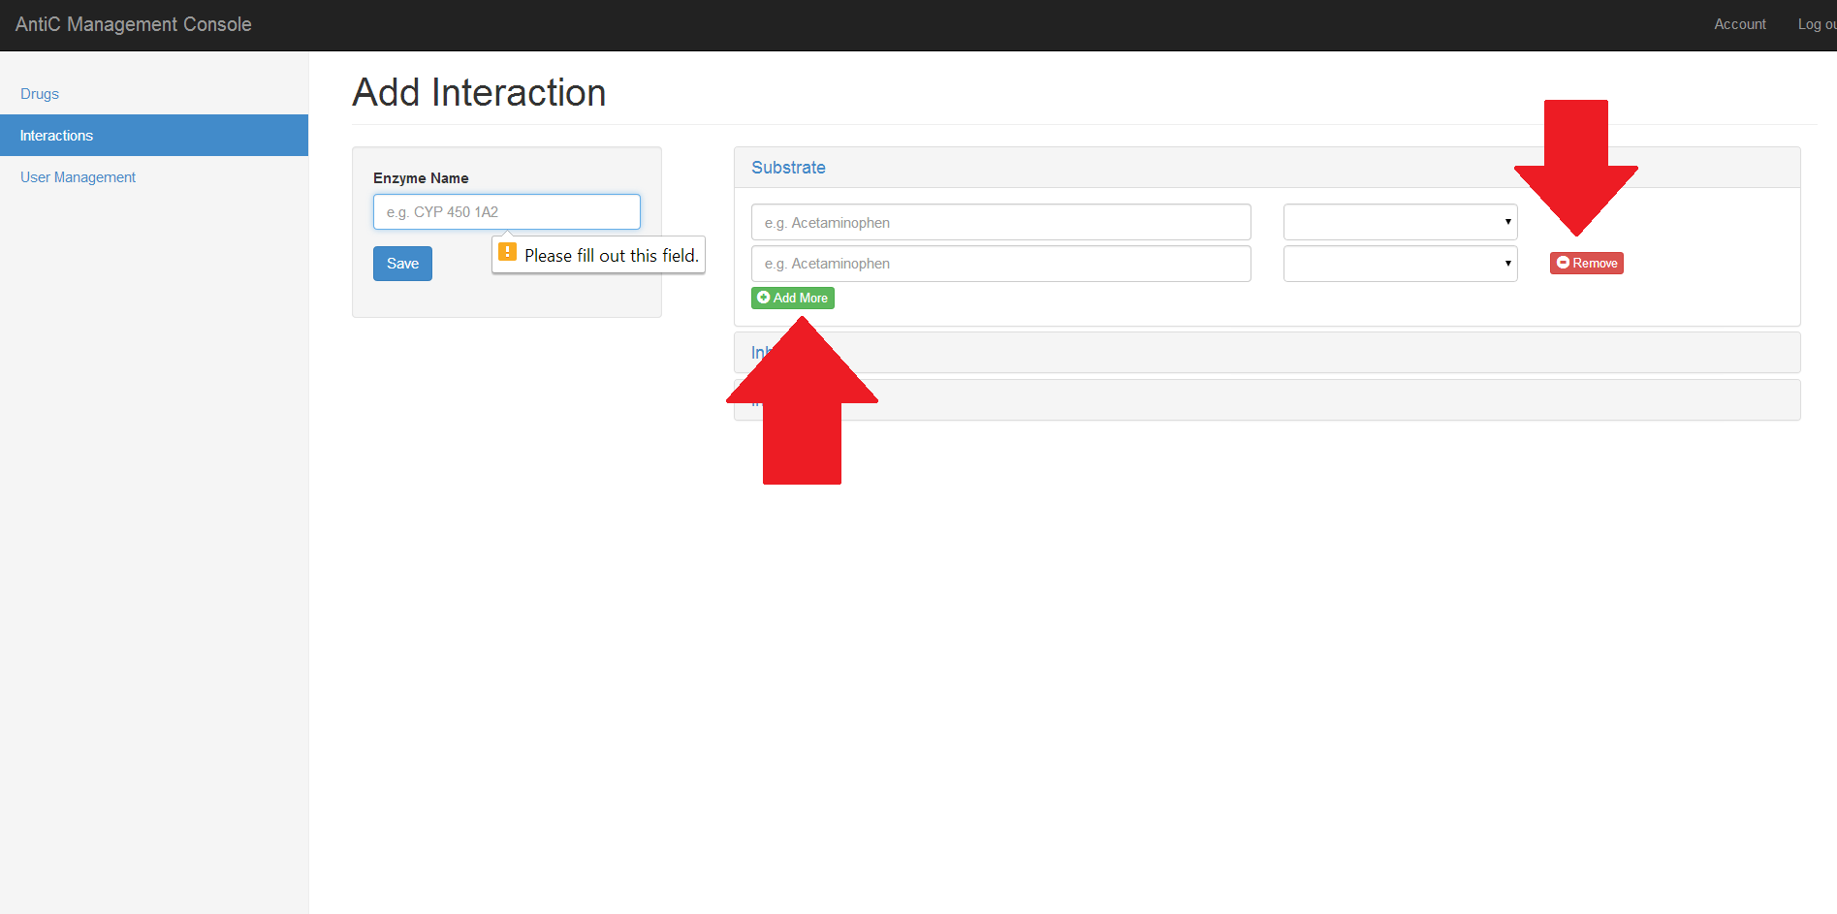

Story ID: 8

1. press "Save Drug"

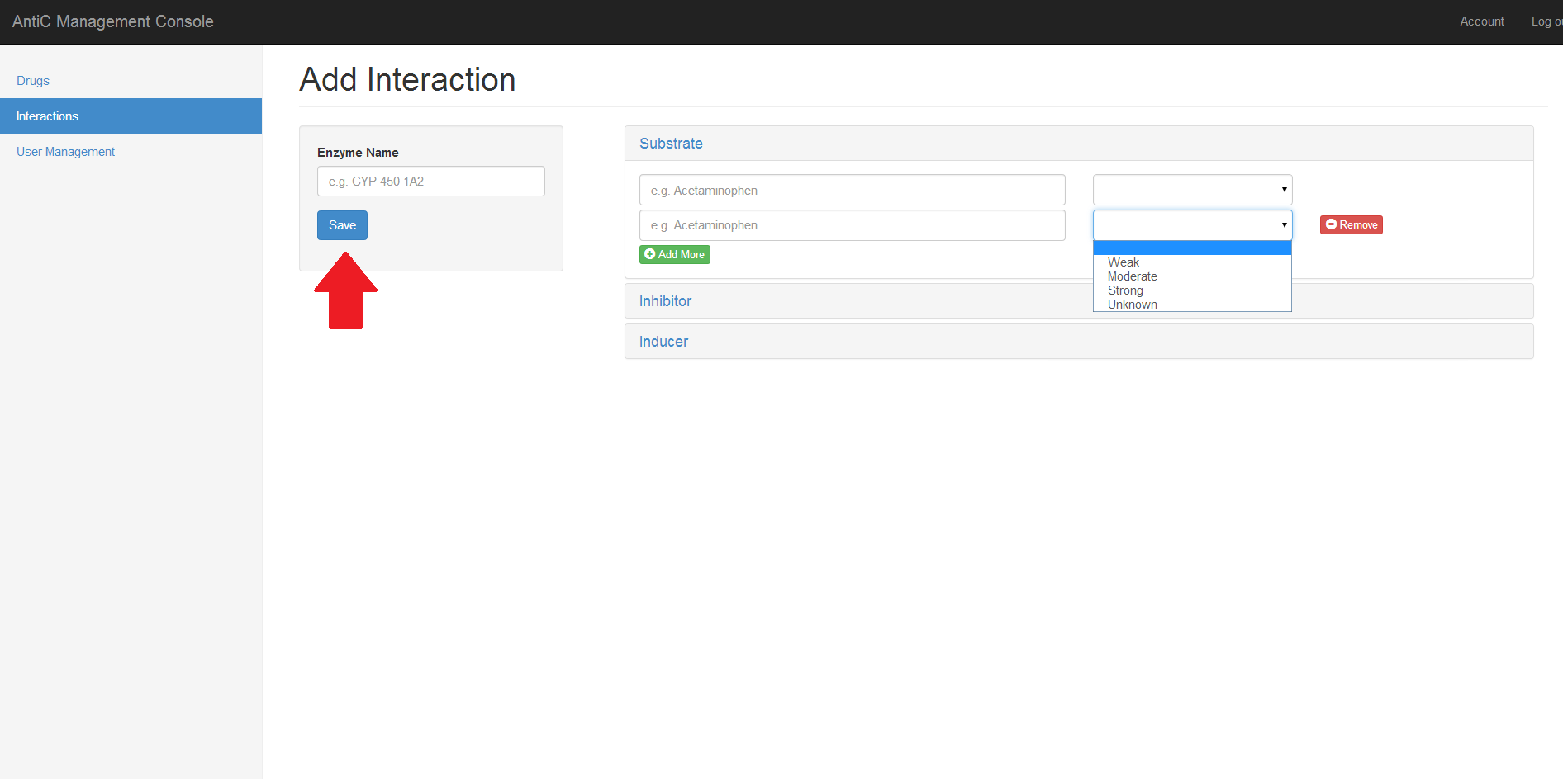

Story ID: 8

Failure:

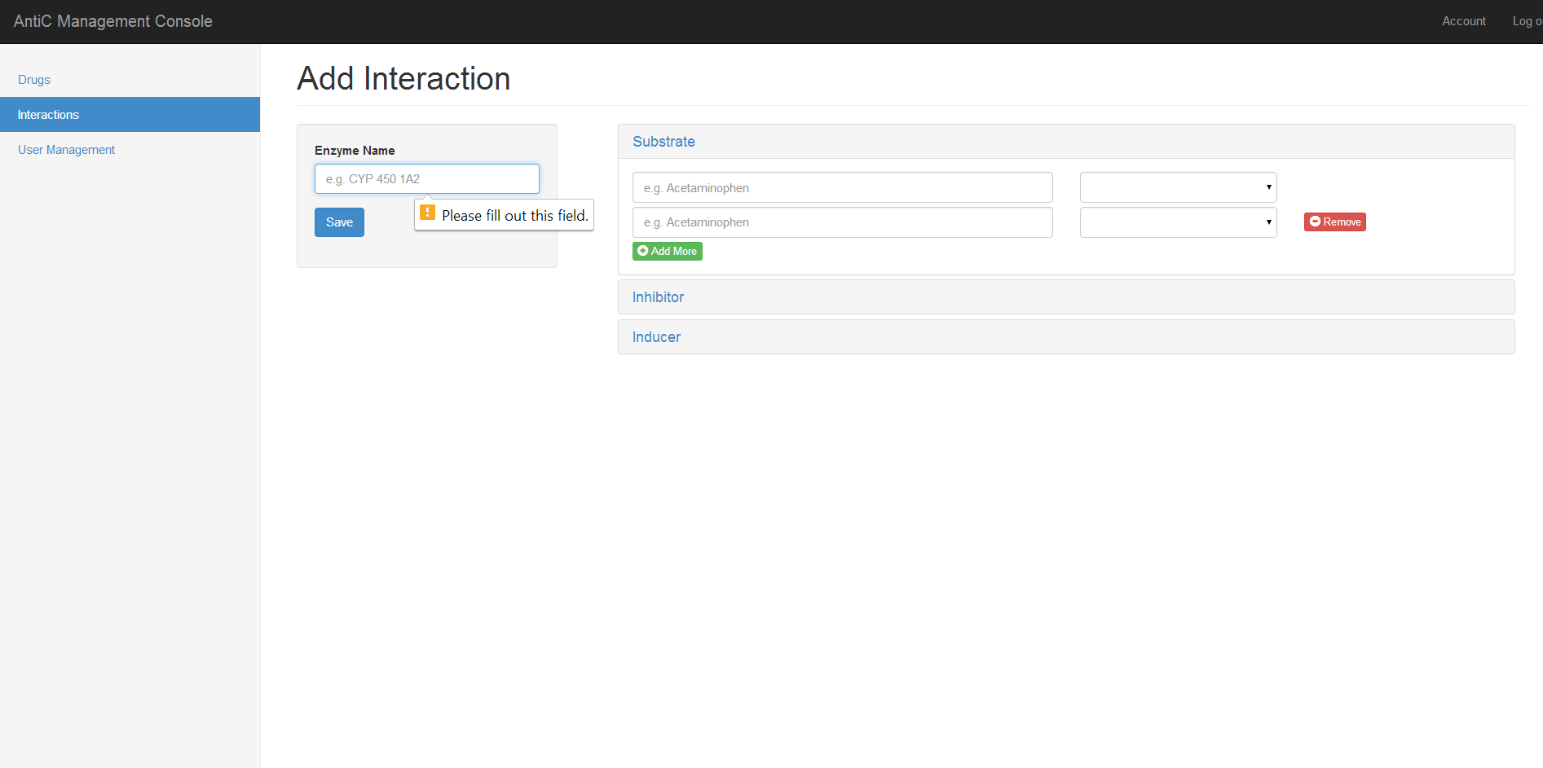 Empty Enzyme Name

Limitations:

Enzyme Name limited at 30 Characters

Compound Name limited at 60 Characters

Story ID: 9

Github ID numbers: #129

Title: 1) I want to alter enzymes that are already present in database

Title: 2) I want to alter enzymes that are already present in website

Title: 3) I want to alter interactions that are already present in database

Title: 4) I want to alter interactions that are already present in website

Overview:

Once an enzyme or interaction has already been placed on the site, this page mimics the “Add” page, but populates it with the enzyme of your choice.

For some fields, a green “add” button is available to add additional fields, or a red “remove” button to remove unused fields.

Steps:

1. Login (Story ID #1)
2. Press “Interactions” if not on Interactions Page



Story ID: 9

1. Click the “Edit” button on the row of my desired enzyme

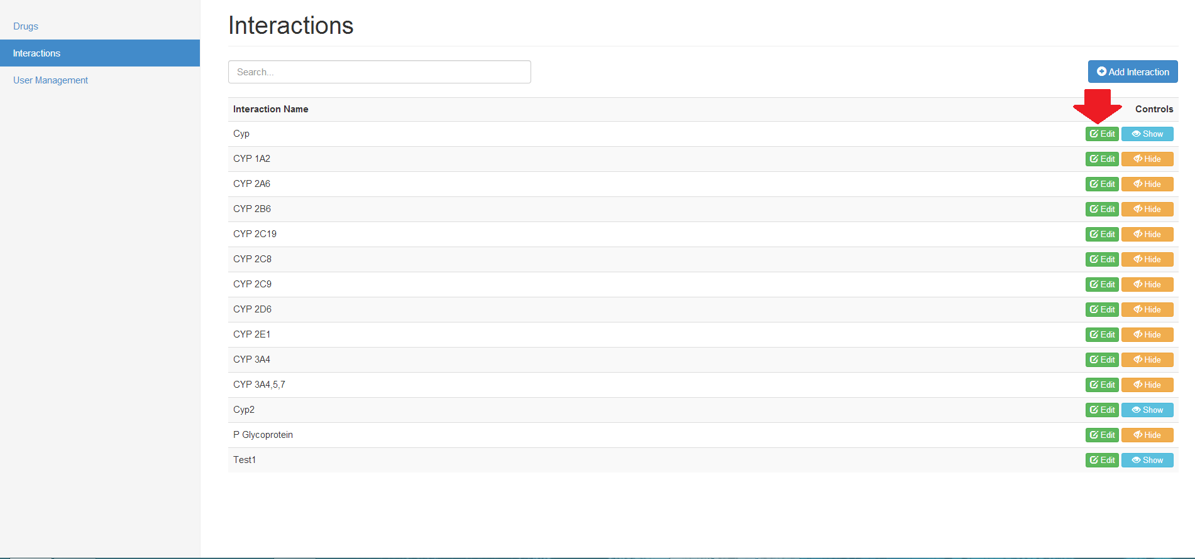

1. The URL should match "/console/interactions/<selected enzyme>"
2. Edit fields as necessary
3. **When done,** press "Save"

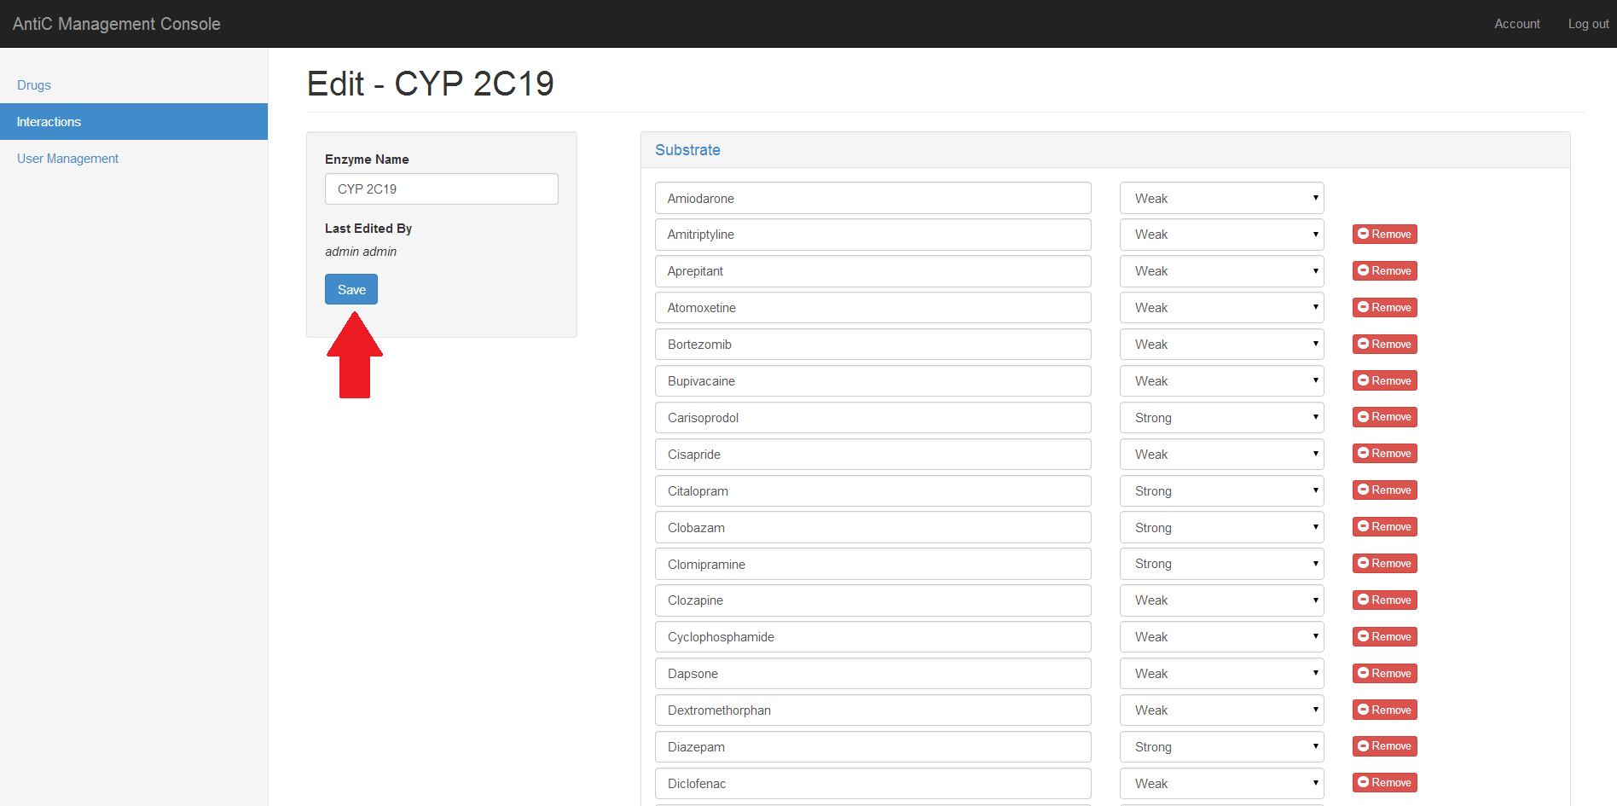

Story ID: 9

Failure:

 Empty Enzyme Name

Limitations:

Enzyme Name limited at 30 Characters

Compound Name limited at 60 Characters

Story ID: 10

Github ID numbers: #151

Title: 1) As an admin, I want to add new users to the website

Overview:

Website Admins should be able to authenticate new users and admins.

Steps:

1. Login (Story ID #1)
2. Press “User Management” if not on Users Page

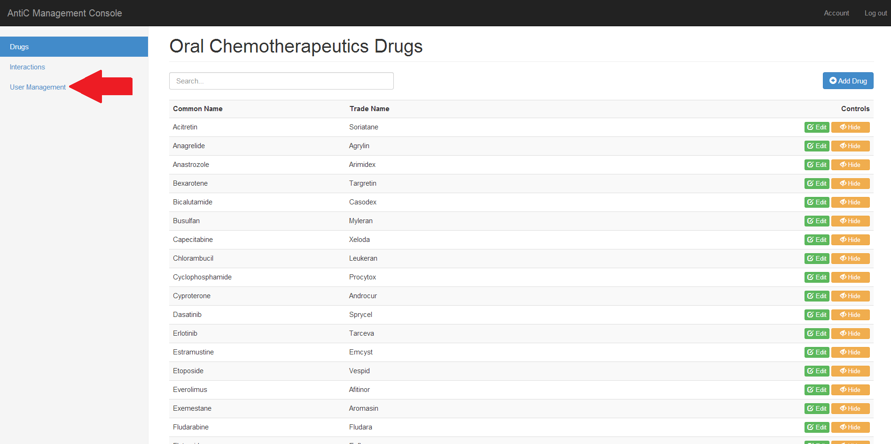

1. Click the “Add User” button

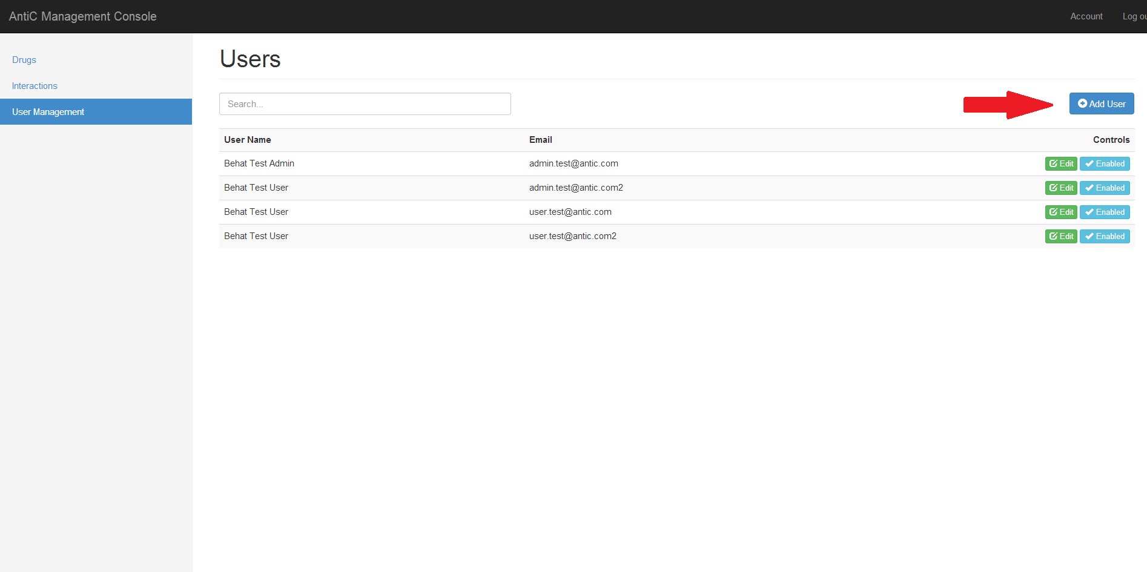

Story ID: 10

1. The URL should match "/console/users/add”
2. Fill all fields with required information
3. Optionally check “ROLE_ADMIN” if you want to authorize a new admin

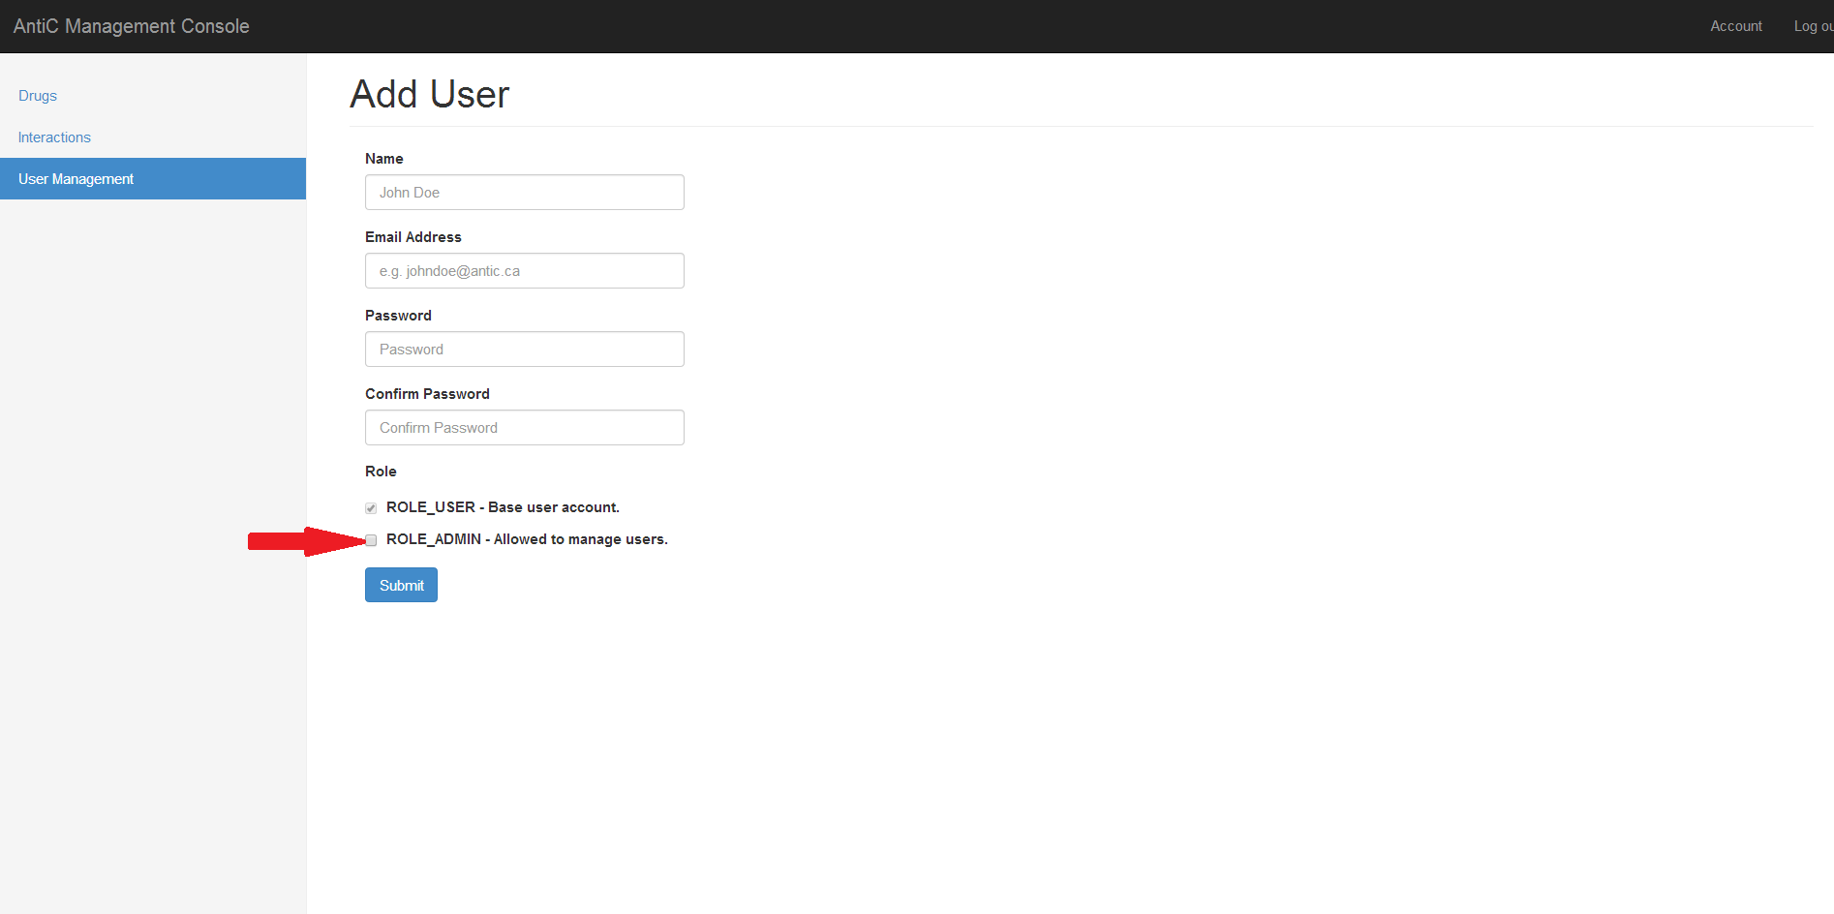

1. **When done,** press "Save"

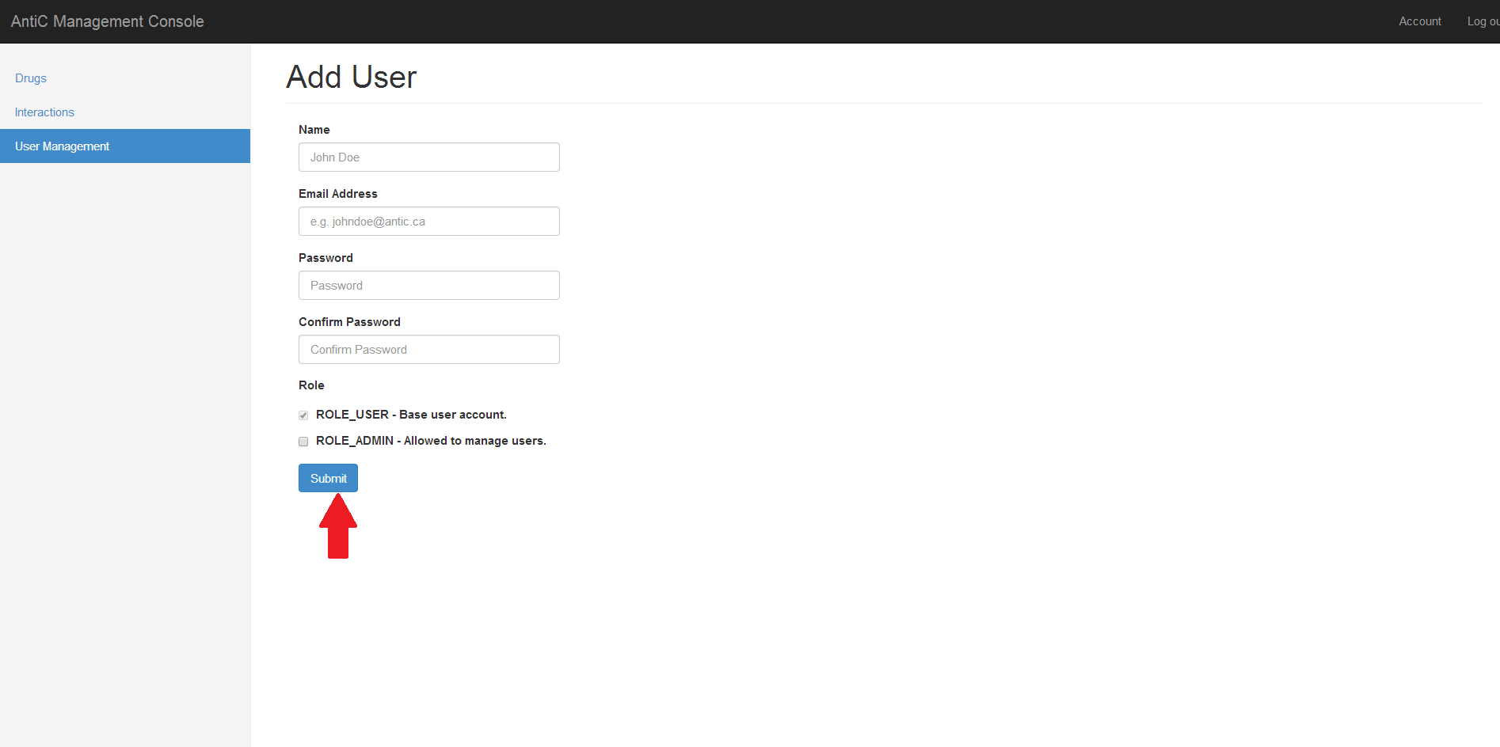

Story ID: 10

Failure:

-All fields are enforced (And have the same pop up as below, on their respective field)

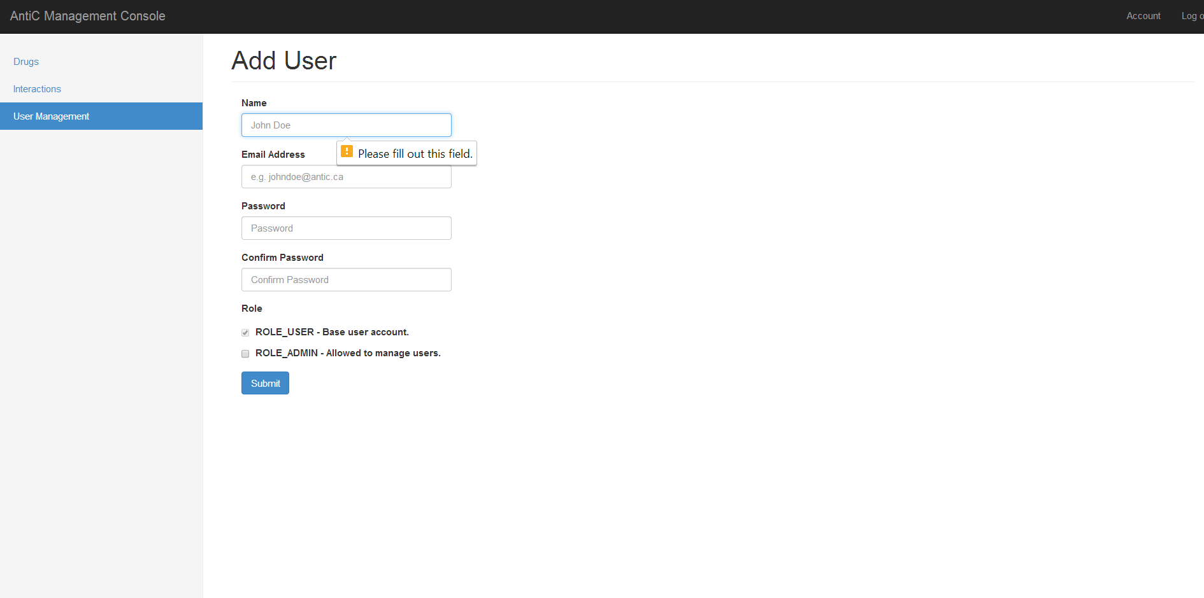

Limitations:

-Name limited to 100 Characters

-Password limited to 32 Characters

-Email limited to 255 Characters

Story ID: 11

Github ID numbers: #151

Title: 1) As an admin, I want to edit users to the website

Overview:

Website Admins should be able to authenticate new users and admins.

Steps:

1. Login (Story ID #1)
2. Press “User Management” if not on Users Page



1. Click the “Edit” button on the row of my desired user

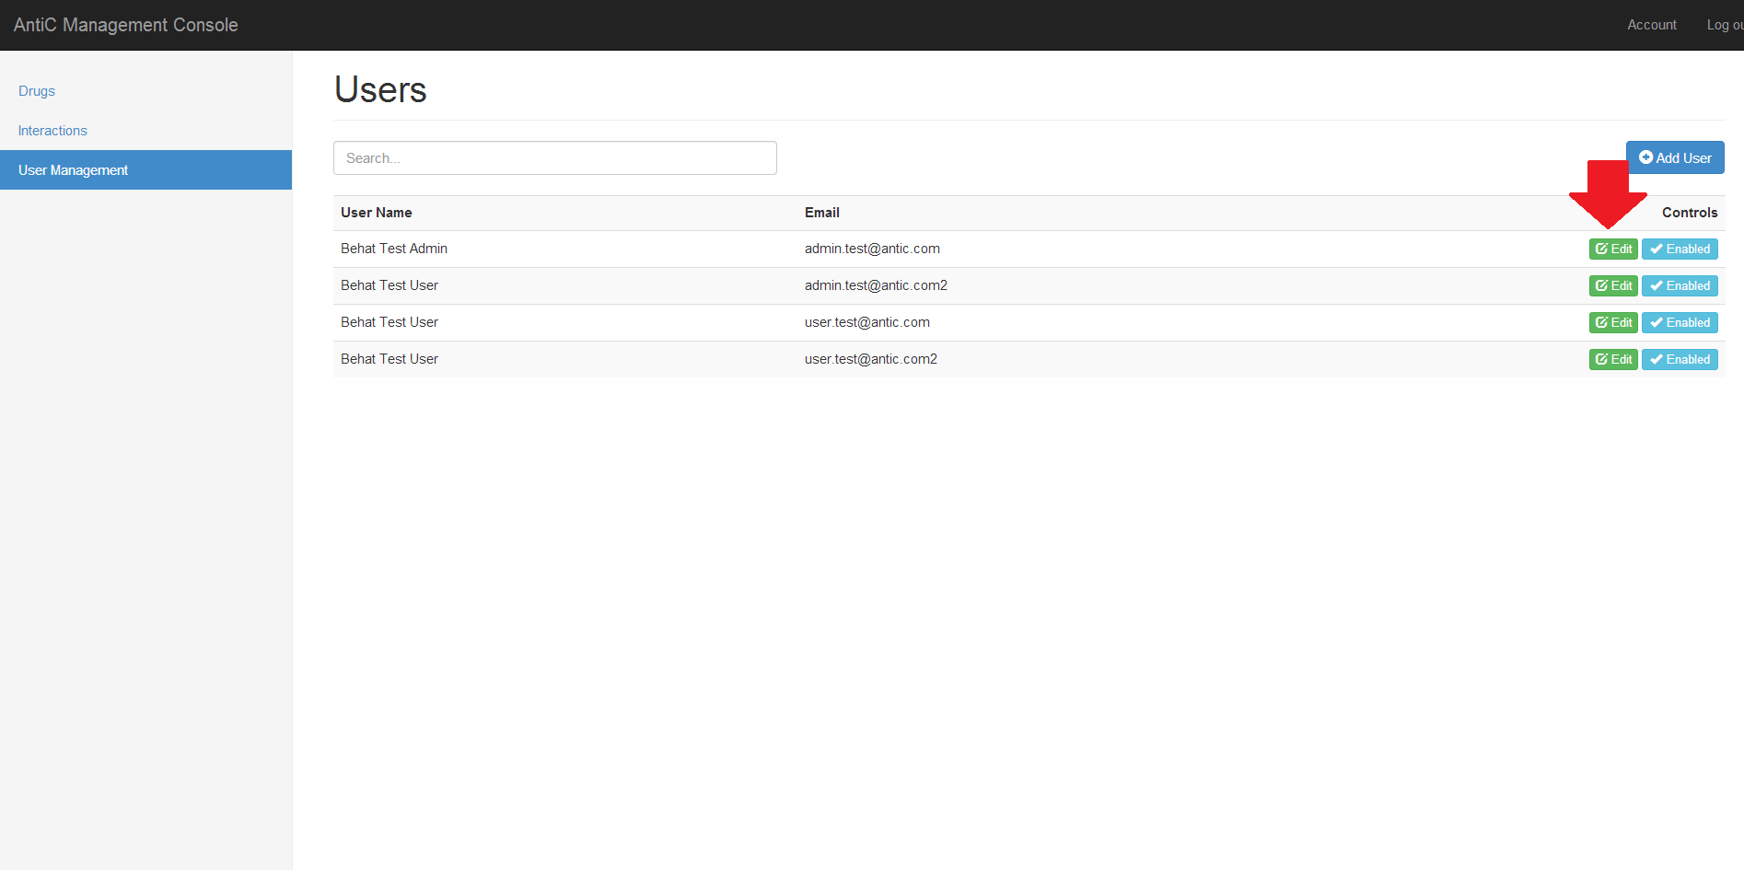

Story ID: 11

1. The URL should match "/console/users/<id>”
2. Edit fields with required information
3. Optionally check “ROLE_ADMIN” if you want to authorize a new admin
4. **When done,** press "Save" (To avoid revealing credentials we have displayed the add page again below, which is identical to the Edit page, except without the user info.)

Failure:

 -All fields are enforced (And have the same pop up as below, on their respective field)

Limitations:

-Name limited to 100 Characters

-Password limited to 32 Characters

-Email limited to 255 Characters

Story ID: 12

Github ID numbers: #129

Title: 1) I want to be able to remove/restore interactions from the database

Title: 2) I want to be able to remove/restore enzyme drugs from the database

Title: 3) I want to be able to remove/restore interactions from the website

Title: 4) I want to be able to remove/restore enzyme drugs from the website

Overview:

When the user wants an enzyme and its interactions to no longer be visible in the public app/ webview, he can disabled it with the “Hide” button. Since medical data is time consuming to enter and may be needed again later, we were directed to hide the info rather than remove it entirely.

Steps:

1. Login (Story ID #1)
2. Press “Interactions” if not on Interactions Page
3. Change the state using the button on the row of the enzyme you desire to hide/show
   1. Press the orange “Hide” button to make invisible
   2. 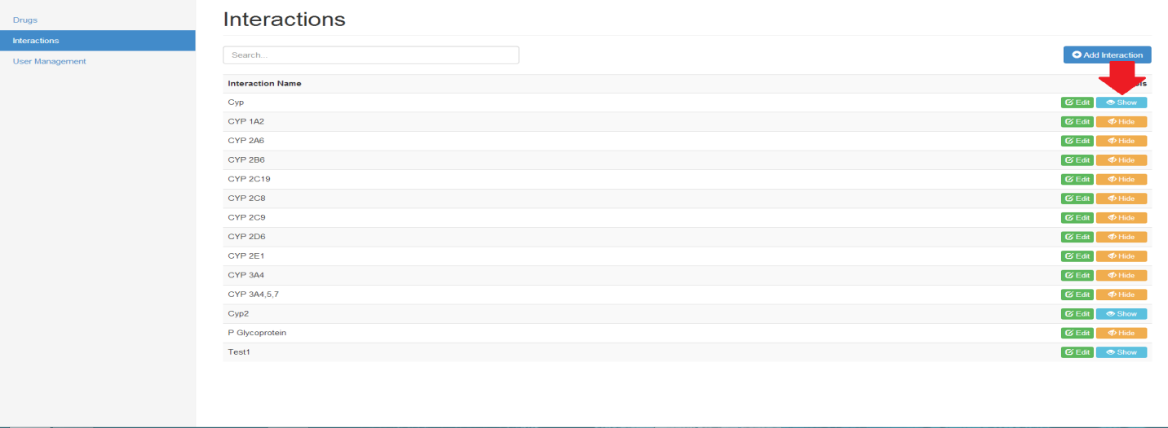Press the blue “Show” button to make visible

Story ID: 13

Github ID numbers: #11

Title: 1) I want to be able to access all the information offline on the app

Overview:

As a medical app, it is essential that this data can be accessed in any environment, so it must be it assumed that it can be used without internet.

Steps:

1. Ensure that (Story ID #7) has been performed at least once, such that you have data on the local app
2. If you have updated at least once, then you can use the app offline

Story ID: 14

Github ID numbers: #6, #7

Title: 1) I want to see a list of all the generic names of the available chemotherapeutic drugs.

Title: 2) I want to see a list of all the trade names of the chemotherapeutic drugs.

Overview:

Every chemotherapy drug has two names, and this story is being able to view both with ease.

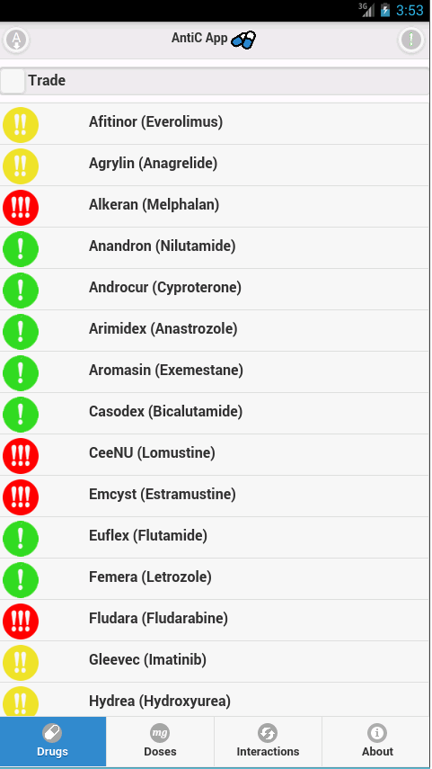 Whatever sort you have will be the first name listed, with the second name in brackets next to it.

Steps:

App:

1. Boot up the app ” (Story ID#26)
2. The main page (labelled drugs on the navigation bar) displays both names

Website

1. Go to <http://54.201.147.95/drugs>, or press “Drugs” on the navbar
2. This page (labelled drugs on the navigation bar) displays Generic Names

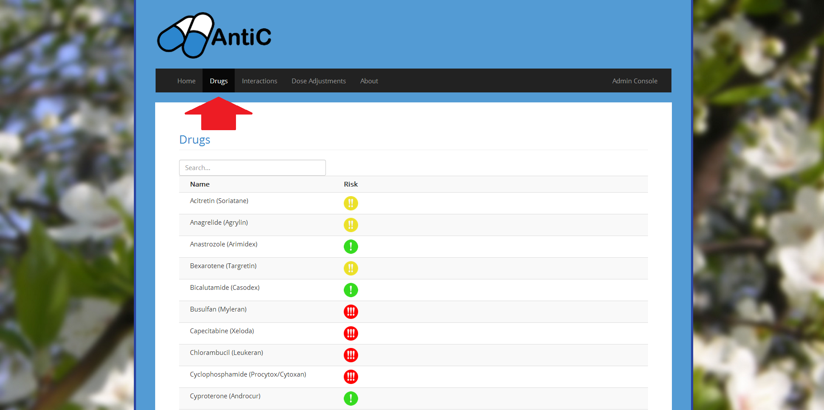

Story ID: 15

Github ID numbers: #8, #10

Title: 1) I want to navigate the list of drugs by the first letter of the name

Title: 2) I want both lists to be ordered alphabetically

Overview:

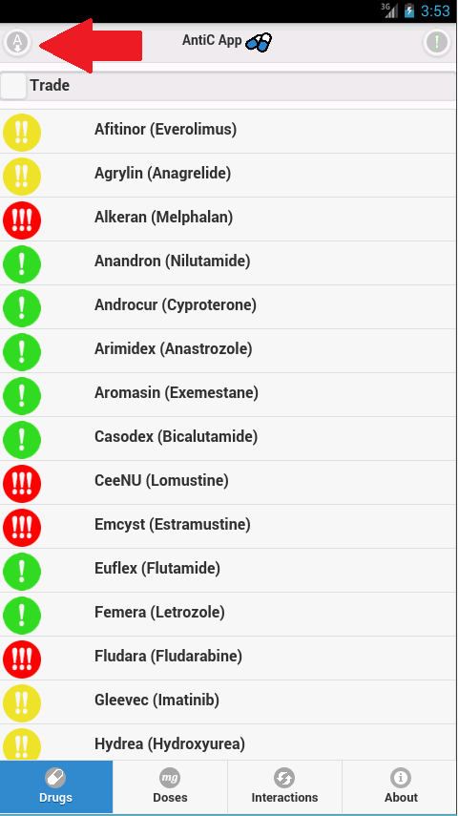 For quick reference the user may want to view the lists by name (which is the default sort)

Steps:

App:

1. Upon loading the app the names should be alphabetized by default (Story ID #26)
2. If the user has been sorting with other filters, they can press the button with the “A” in the top left
   1. The first press sorts alphabetically A🡪Z
   2. The second press sorts reverse alphabetically Z🡪A
   3. Further presses will toggle these two states

Website:

1. Go to <http://54.201.147.95/drugs>, or press “Drugs” on the navbar
2. The drugs should be alphabetical by default



Story ID: 16

Github ID numbers: #9

Title: 1) I want to easily be able to switch from one list of names to the other via a switch on the GUI on the app.

Overview:

Different medical professionals will have prefers for the name they want to sort by.

The app will remember your preferred state.

Steps:

1. Boot up the App (Story ID #26)
2. On the top of the App is a toggle button. By default this says trade, but may say generic is if has been used already
3. Pressing this will toggle the button between states
   1. The toggle is grey and displays “Trade”, to sort by trade name
   2. The toggle is blue and displays “Generic”, to sort by generic name

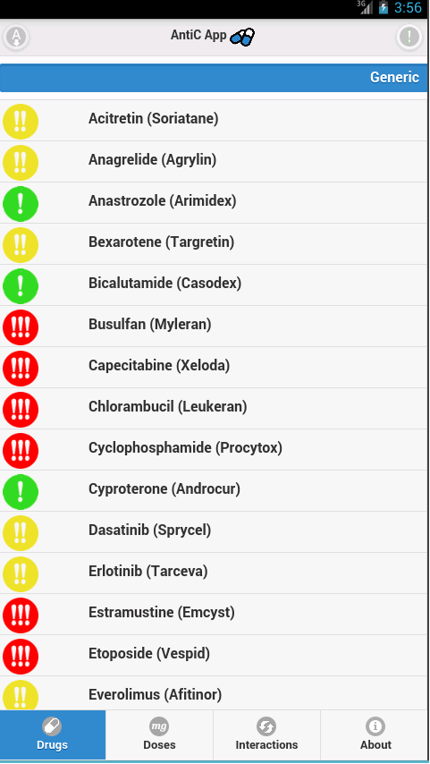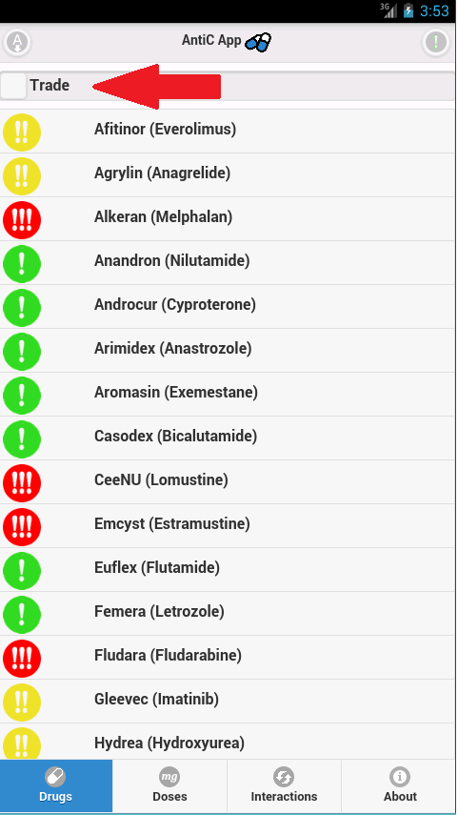

Story ID: 17

Github ID numbers: #12, #13, #99, #100, #286

Title: 1) I want to be able to organize the drugs on the app by the risk level of the drug

Title: 2) I want the drugs to be labeled by their risk level (by an icon)

Overview:

In some situations the user may desire to sort the drugs by their relative risk level, rather than their name

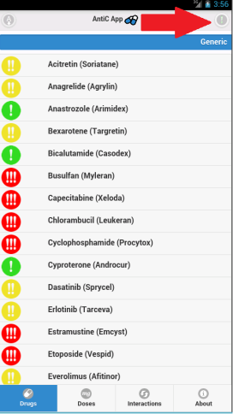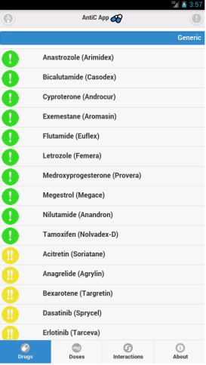Steps:

App:

1. Upon loading the app the names should be alphabetized by default (Story ID #26)
2. The user can press the button with the “!” in the top right
   1. The first press sorts from low risk (Green) to high risk (Red)
   2. The second press sorts from high risk (Red) to low risk (Green)
   3. Further presses will toggle these two states

Website:

1. Go to <http://54.201.147.95/drugs>, or press “Drugs” on the navbar
2. Risk Levels are shown to the right of each drug.



Story ID: 18

Github ID numbers: #14, #37, #38, #109, #157, #275

Title: 1) When I select the drug I want to be taken to that drugs information

Title: 2) I want to find drugs to give to my patient quickly

Title: 3) I want to find drugs to give to my patient accurately

Overview:

Once the user has chosen a given drug, they will want to look into all of the specific details of that drug

Steps:

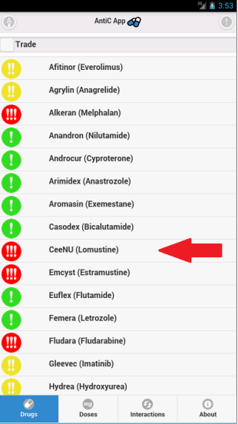 App:

1. Boot up the App (Story ID #26)
2. From the main page, locate the drug of your desire on click on its name
3. The user should now be on the information page for that specific drug
4. The may click on a category to expand the information, or click the “+/-” in the top right to open/close all tabs.
5. 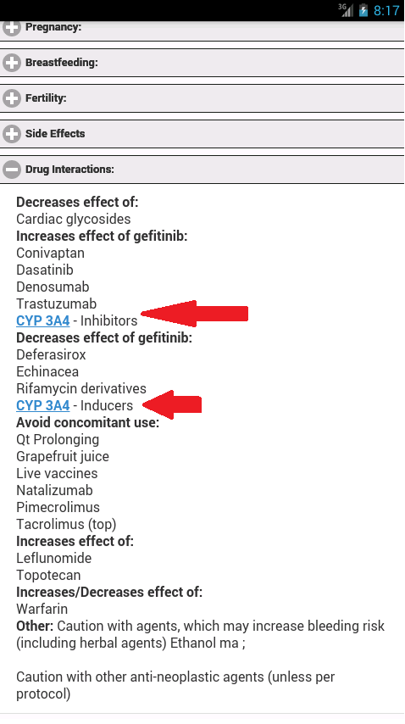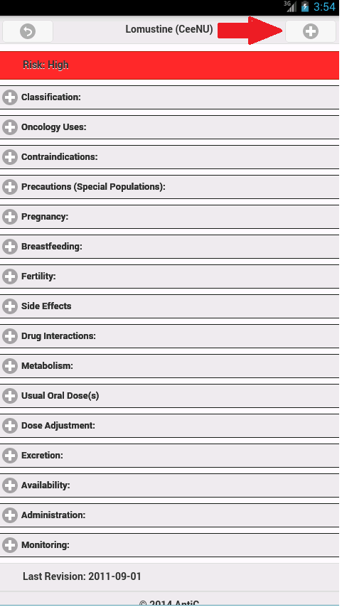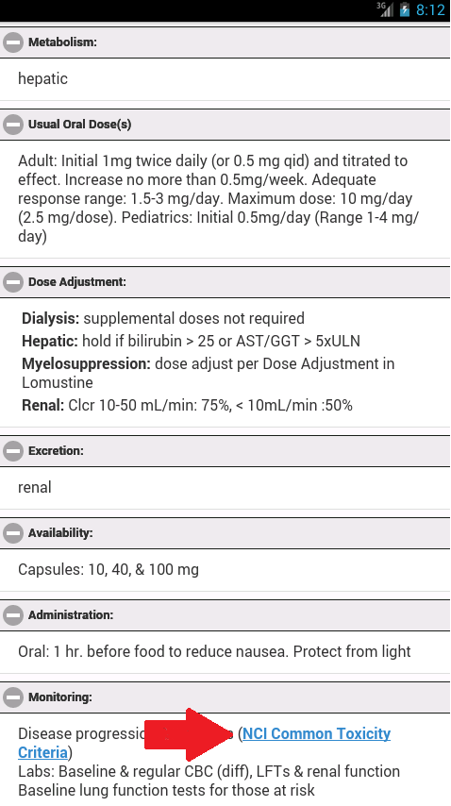If a user desires, they may click hyperlinked text that will take them to other resources and interactions.

Story ID: 18

Website:

1. Go to <http://54.201.147.95/drugs>, or press “Drugs” on the navbar
2. 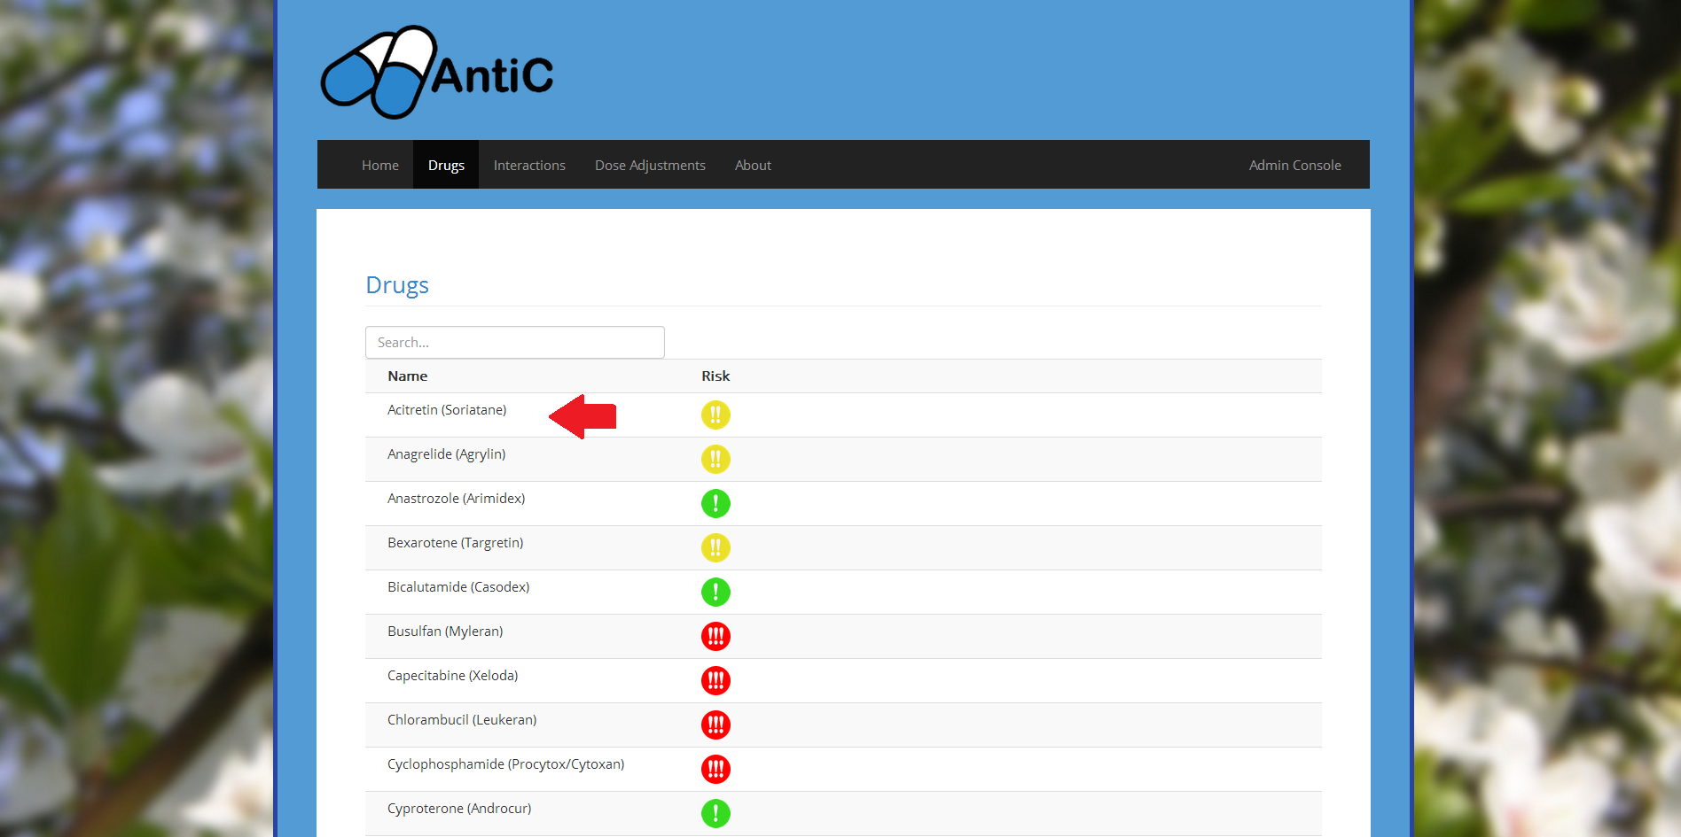Locate the drug of your desire on click on its name

Story ID: 18

1. The user should now be on the information page for that specific drug

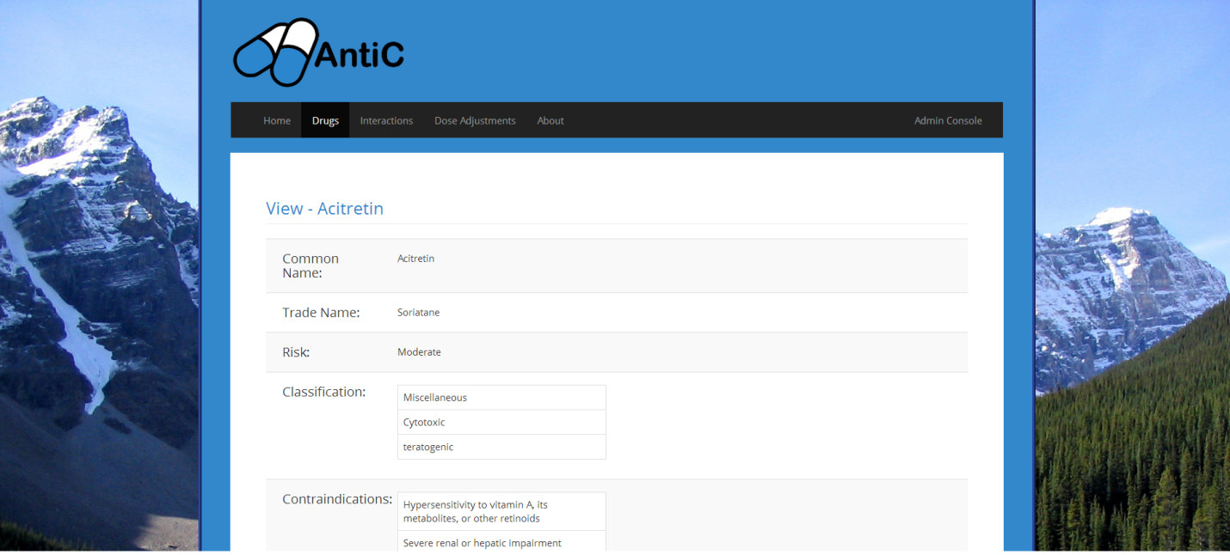

Story ID: 19

Github ID numbers: #18, #19, #102, #199

Title: 1) I want to be able to browse drug interactions by liver enzymes, and view their relevant data

Overview:

A user may want to check to see if a particular compound is interacting with a crucial enzyme for their patient. The interaction level is displayed on the side.

Steps:

App:

1. Boot up the App (Story ID #26)
2. From the main page, click the “Interactions” button on the bottom navigation bar
3. From the enzyme page, locate the enzyme of your desire on click on its name
4. The user should now be on the information page for that specific enzyme

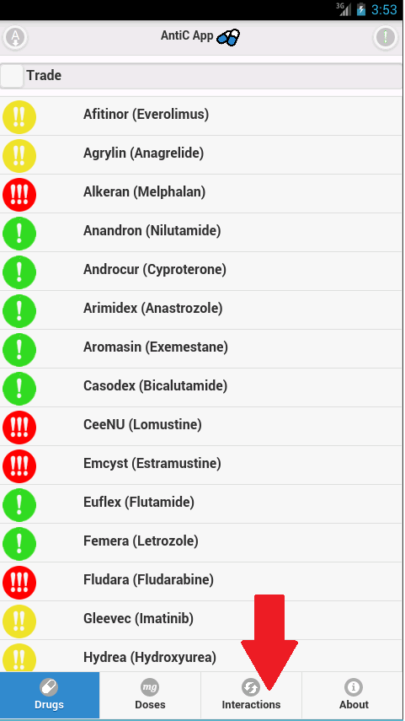

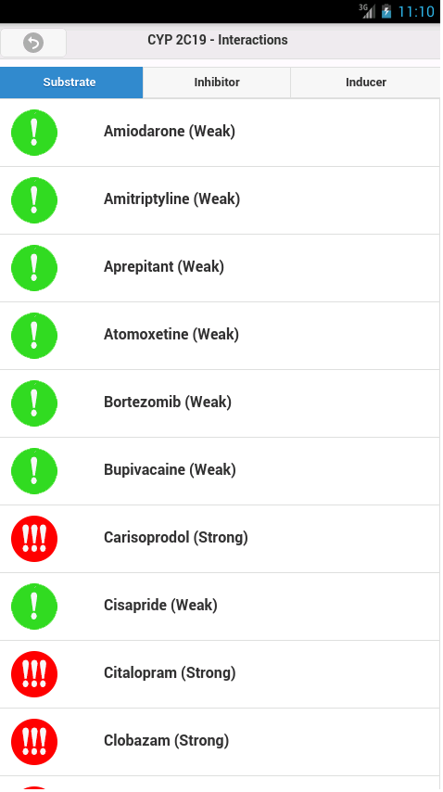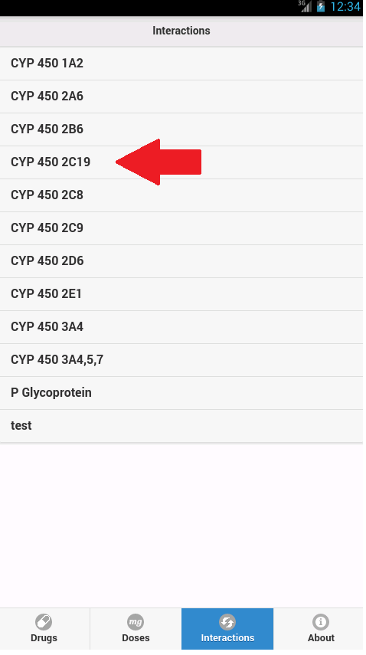

Story ID: 19

Website:

1. Go to <http://54.201.147.95/interactions>, or press “Interactions” on the navbar

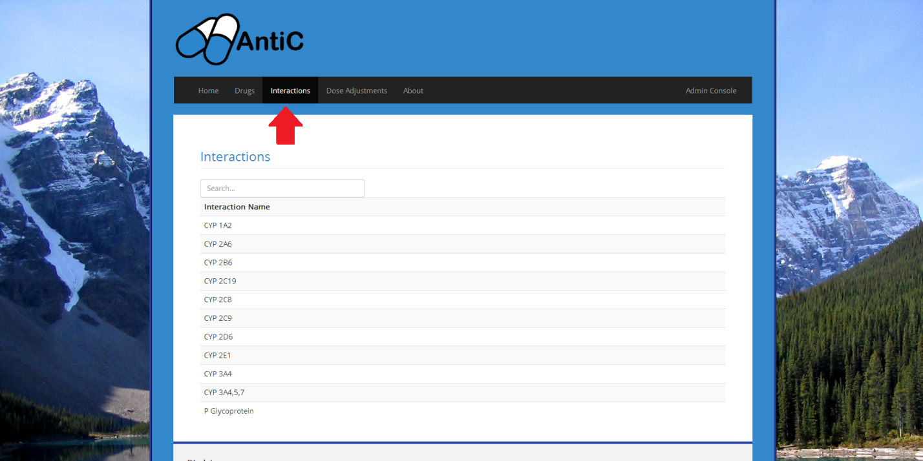

1. From this page, locate the enzyme of your desire on click on its name

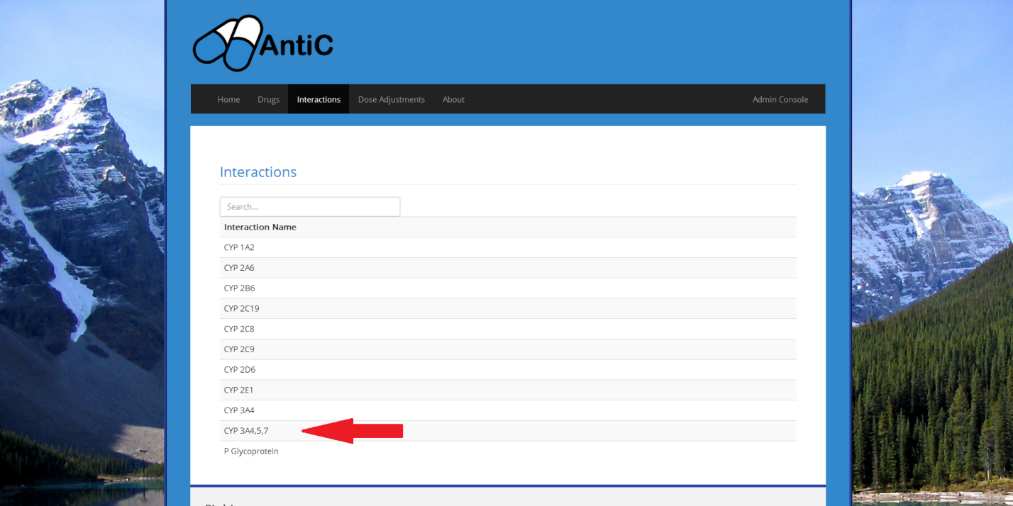

Story ID: 19

1. The user should now be on the information page for that specific enzyme

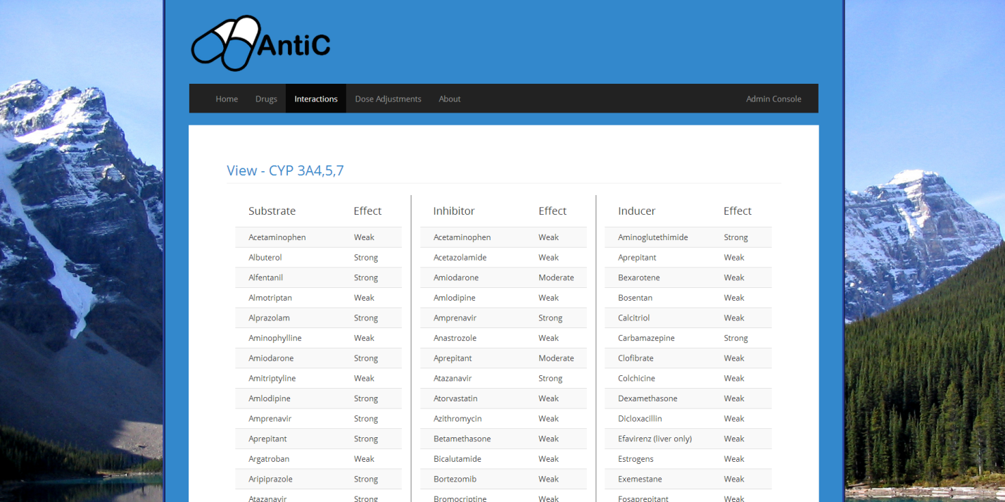Story ID: 20

Github ID numbers: #20

Title: 1) I want the interactions to be organized by type (substrate, inhibitor, inducer)

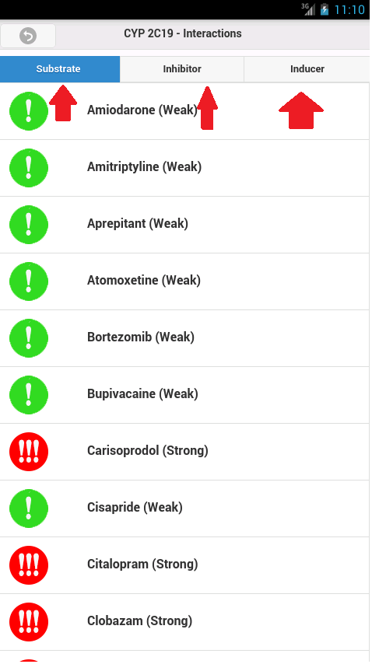Overview:

Enzyme Interactions fall into 3 groups, which I want to use to distinguish interactions

Steps:

App:

1. Follow (Story ID# 19)
2. Choose your desired interaction type (substrate, inducer, inhibitor) from the navigation bar in the top of the page

Website:

1. After following Story ID #19, all 3 categories should be visible



Story ID: 21

Github ID numbers: #9, #12

Title: 1) I want to be able to choose different filters via a drop down menu on the app.

Overview:

A user may need to filter the drug list

Steps:

1. Boot up the App
2. Choose the appropriate filter for your needs
   1. By Alphabet (Story ID# 15)
   2. By Trade/Generic Name (Story ID# 16)
   3. By Risk (Story ID# 17)

Story ID: 22

Github ID numbers: #14, , #18, #19, #20, #21, #37, #38, #39, #102, #109, #143, #144, #145, #157, #199 , #280

Title: 1) I want to navigate between pages using the navigation bar

Overview:

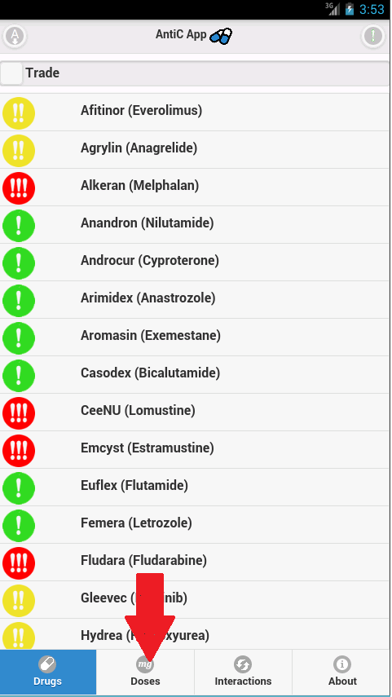 The user should be able to navigate through the different categories of the app. If desired, back buttons appear in the top left of some pages

Steps:

App:

1. Boot the App (Story ID #26)
2. On the bottom bar, click the name of the page you wish to navigate to (example to the right)
   1. Drugs
   2. Dose Adjustments
   3. Interactions
   4. About

Website:

1. Go to <http://54.201.147.95/>
2. On the top bar, click the name of the page you wish to navigate to (Example Below)
   1. Home
   2. Drugs
   3. Dose Adjustments
   4. Interactions
   5. About
   6. Admin Console



Story ID: 23

Github ID numbers: #21, #39, #143, #144, #145

Title: 1) I want to press “About” and see the overview of the current version of the project

Title: 2) I want to press “About” and see the current version of the application

Title: 3) I want to view the disclaimer for the risks associated with these drugs

Title: 4) I want to view a glossary of unfamiliar medical terms

Overview:

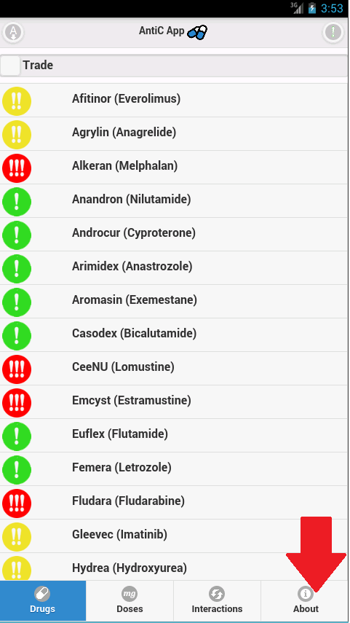 The user should be able view reference and additional information about the app

Steps:

App:

1. Boot up the App (Story ID #26)
2. From the main page, click the “About” button on the bottom navigation bar
3. The disclaimer will be immediately shown
4. The User can scroll down and expand/collapse tabs
   1. Legend
   2. Glossary
   3. The Team
   4. Resources
   5. Version

Website:

1. <http://54.201.147.95/about>, or press “About” on the navbar
2. 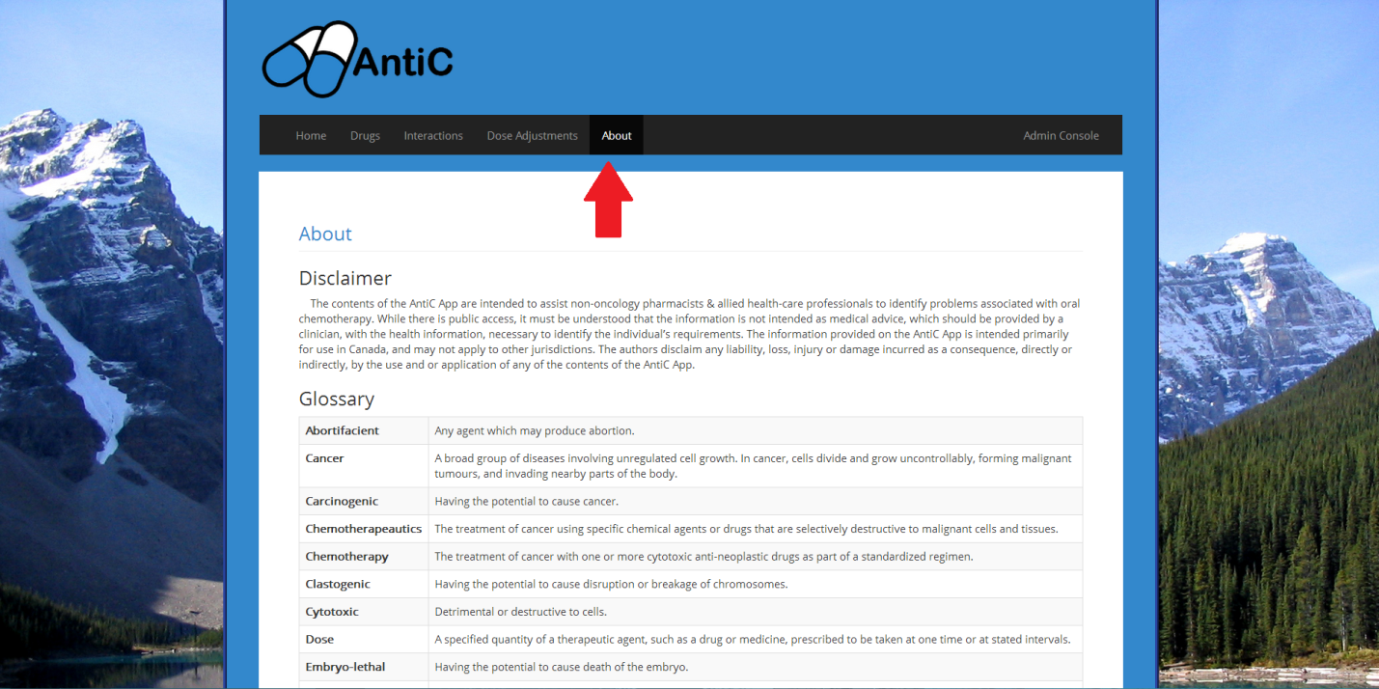All data should be displayed.

Story ID: 24

Github ID numbers: #103, #280

Title: 1) I want to be able to view the dose adjustments for any drug that has one

Overview:

The user may be interested in viewing an alternate dose adjustment for the drug they would like to give their patient

Steps:

App:

1. Boot up the App (Story ID #26)
2. From the main page, click the “Dose Adjustments” button on the bottom navigation bar
3. From the dose page, locate the drug/adjustment of your desire on click on its name
4. The user should now be on the dose adjustment information page for that specific drug

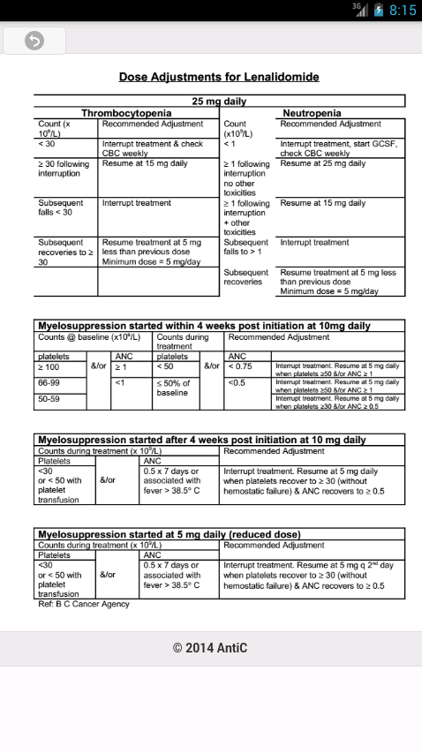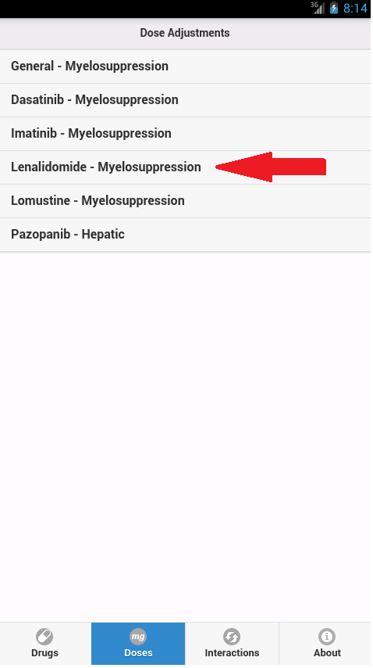

Story ID: 24

Website:

1. Go to <http://54.201.147.95/doseadjust>, or press “Dose Adjustments” from the navbar

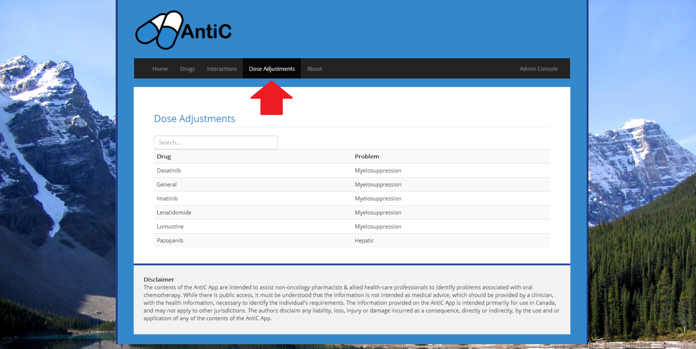

1. From the dose page, locate the drug/adjustment of your desire on click on its name

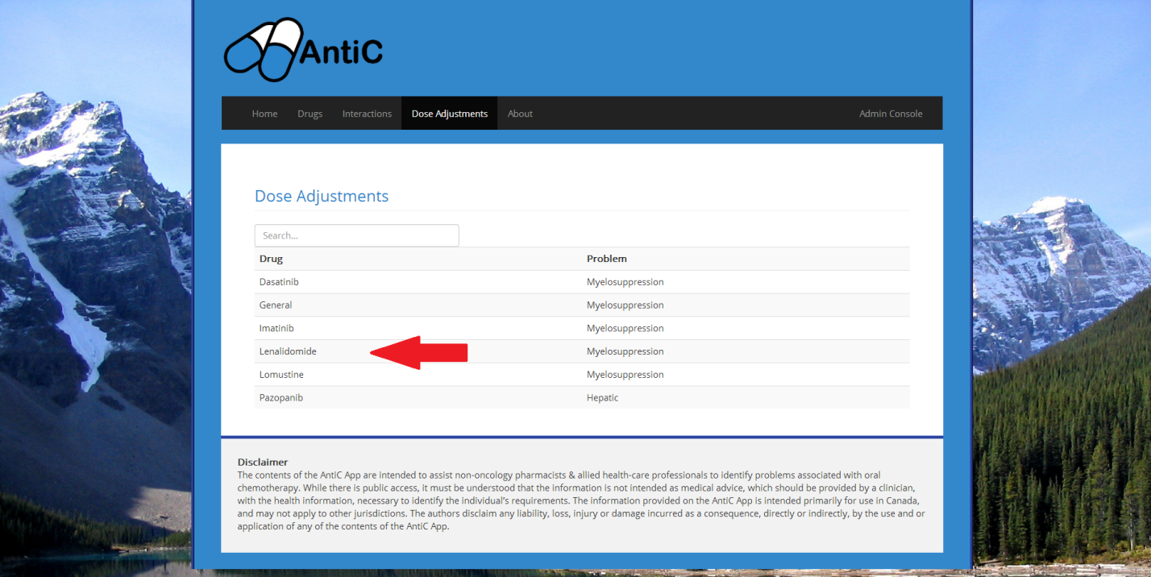

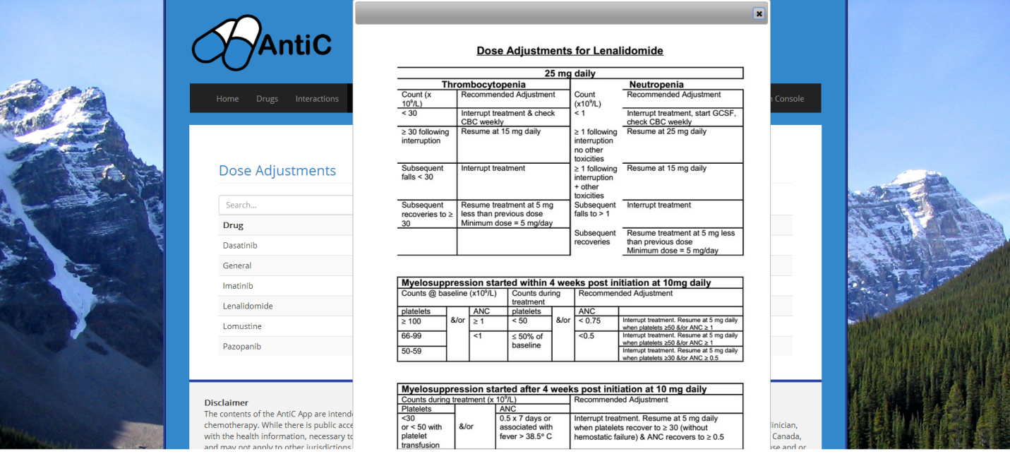Story ID: 24

1. The user should now be on the dose adjustment information page for that specific drug
2. 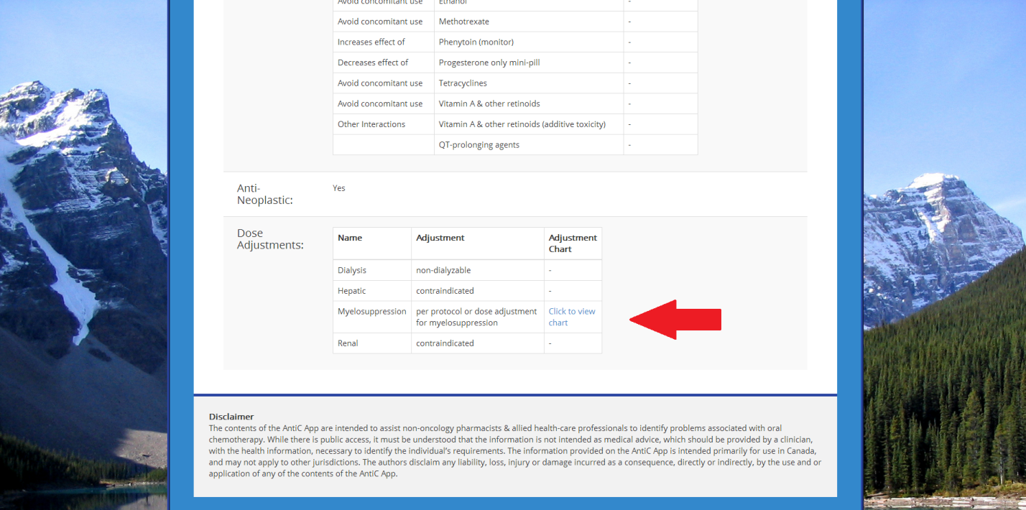Alternatively, the user can also reach dose adjustments in the “Dose Adjustments” section of a drugs information sheet

Story ID: 25

Github ID numbers: #90, #126

Title: 1) As a authorize website admin/user, I want to edit my account

Overview:

Website Admins should be able to authenticate new users and admins.

Steps:

1. Login (Story ID #1)
2. Press “Account” on the top bar

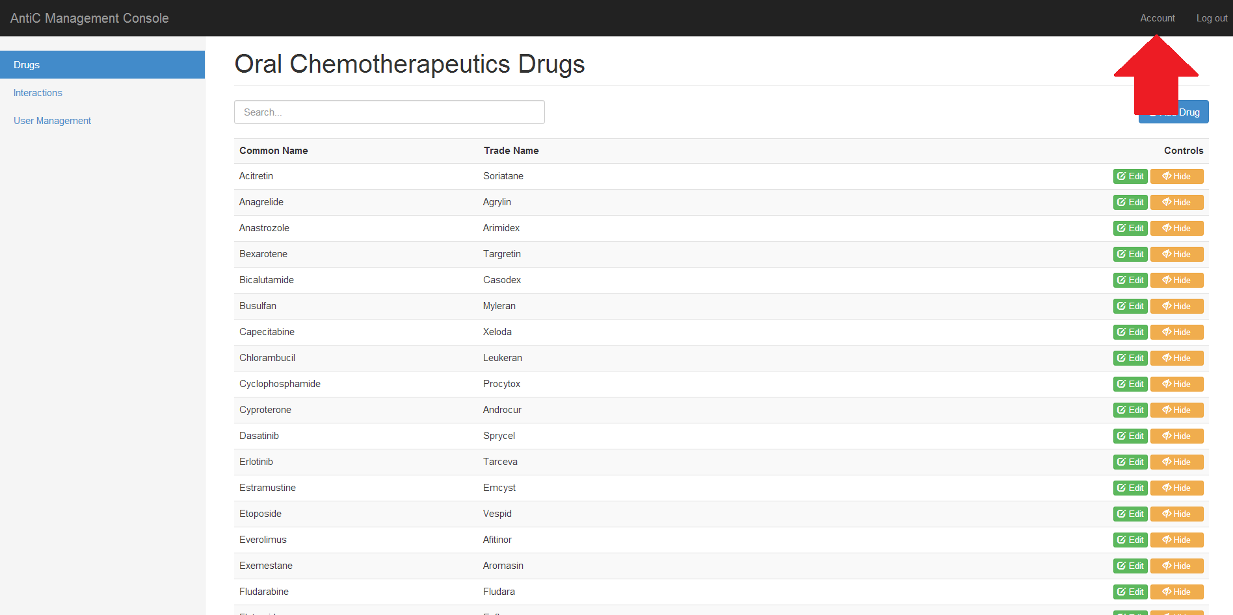

1. The URL should match "/console/account”
2. Edit fields with required information

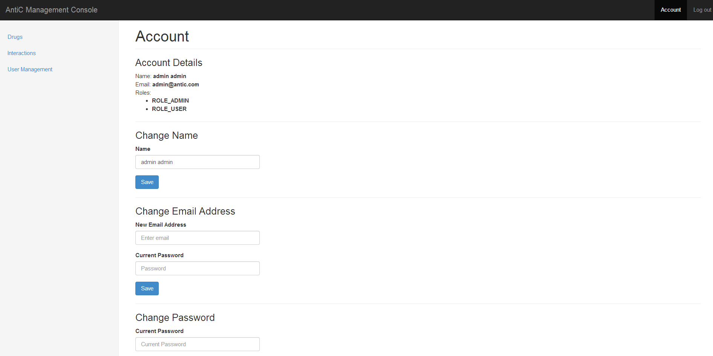

1. **When done,** press "Save" on the corresponding category

Story ID: 25

Failure:

-All fields are enforced

Limitations:

-Name limited to 100 Characters

-Password limited to 32 Characters

-Email limited to 255 Characters

Story ID: #26

Github ID: Not needed, simply a supplementary story to help new users.

Title: 1) Boot the App.

Overview:

Simple Startup

Steps:

1. Click the AntiC icon
2. Read the Disclaimer thoroughly
3. Accept the disclaimer once you have read and understand its contents
4. If new medical data is available, you will need to follow Story ID #7

Exception:

If you do not agree to the disclaimer, you can exit the application.

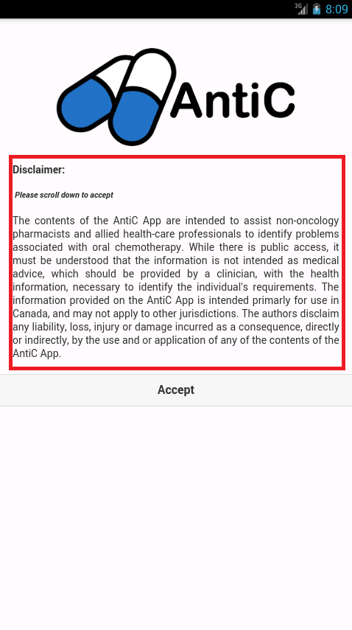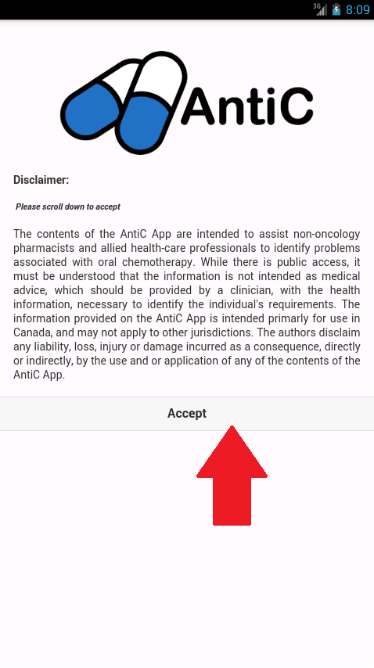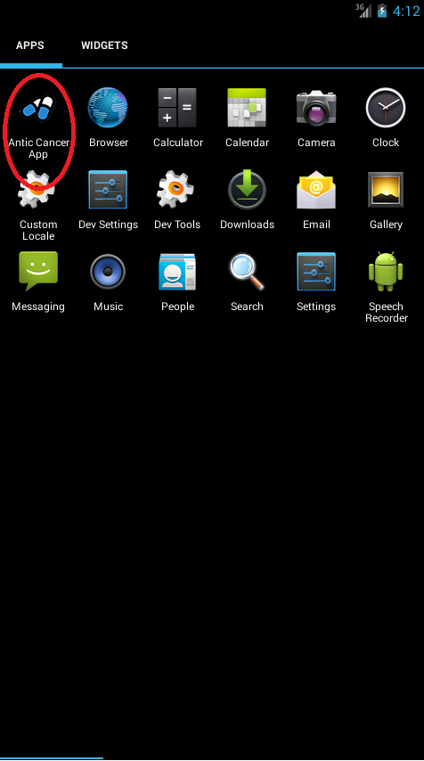

List of removed stories:

Our client requested that we remove “Protocols” from the app #101, #127, #128, #220, #221, #222

I want to add new Protocols into the database via the website

I want to be able to delete protocols from the database

I want to add new Protocols into the website

I want to be able to delete protocols from the website

I want to be able to view the protocol for any drug that has one

Our client requested we simplify options and remove the options page

I want to access advanced obtains by clicked the options button

# #97 Options Page should be able to store settings for default sort

# #98 Options page should let the user choose font size

This story is just vague and untestable

#40 I want this application to be easy to use

This story is too generalized for a mobile app

#41 I want this application to run on my mobile devices

Optional – These were listed as optional originally, and we ended up discarding them

# #16 I want to be able to enter the name of the medication my patient is taking

# #17 I want to see a list of chemotherapy drugs that medication interacts with

# Many Behat Tests were implemented before our TA’s recommended alternative testing methods. These Behat tests located in Antic/features

# *List of partial Behat Tests*

Boot.feature

-List HTML Files

-List other main files

-List Javascript Files – classes

-List Javascript Files – js

Mobile.1.Feature

-Every possible way to navigate between pages is tested

Mobile.5.About

-Checks the content of the about page

Website.admin.1.login.feature

-Checks boundary cases for login information

Website.admin.3.interactions.feature

-Checks different cases for adding/editing interactions

***List of unimplemented Behat Tests:***

Mobile.2.index-drug.feature

-Tests every feature of the drug page

Mobile.3.dose.feature

-Tests every feature of the dose page

Mobile.4.interaction-enzyme.feature

-Tests every feature of interactions and enzymes

Website.admin.2.drug.feature

-Checks different cases for adding/editing drugs

Website.admin.4.user.feature

-Checks different cases for adding/editing users

Website.admin.6.account.feature

-Checks different cases for editing an account

Website.web.1.home.feature

-Checks the content of the home page

Website.web.2.drug.feature

-Checks the functionality of viewing drugs

Website.web.3.interaction.feature

-Checks the functionality of viewing interactions

Website.web.4.about.feature

-Checks the functionality of viewing the about page

Website.web.5.dose.feature

-Checks the functionality of viewing dose adjustments

***PHP UNIT Tests***

Unit Manager Test

-Test loading of User by Username (Email)

-Test Refresh User

-Test the Find One By Method

-Test that Encoding

-Test Create User

-Test the Insert Functionality

-Tests the Update Functionality

-Tests the Delete Functionality

***List of API tests***

Drug Feature

-Check that a new drug is added successfully

-Check that an existing drug is edited successfully

-Check that an existing drug is removed/hidden successfully

-Check that other tables are also changed when a drug is changed

Drug Boundary Features

-Check that a new drug is not added when the same drug exists

-Check that a new drug is not added when primary keys are missing

-Check that an existing drug is not edited when primary keys are missing

Enzyme Feature

-Check that a new enzyme is added successfully

-Check that an existing enzyme is edited successfully

-Check that an existing enzyme is removed/hidden successfully

-Check that rows in other tables are changed when an enzyme is changed.

Enzyme Boundary Cases

-Check that a new enzyme is not added when the same enzyme exists

-Check that a new enzyme is not added when primary keys are missing

-Check that an existing enzyme is not edited when primary keys are missing

***HTML/JS Testing***

Testcypenzyme.js Tests Cyp Enzyme class

- testAttributes()

- testAccessorMethods()

Testdoseadjustments.js Tests dose adjustment class

- testAttributes()

-testAccessorMethods()

Testdrug.js Tests drug class

- testDrugAttributes()

- testAccessorMethods()

Testoncology.js Tests oncology use class

- testAttributes()

- testAccessorMethods()

Testinteractions.js Test interaction class

- testAttributes()

- testAccessorMethods()

Testmenu.js Tests listview main menu that lists all drugs

-testSort()

-testRiskSort()

-testPopulation()

Testprotocol.js Tests protocol class

- testAttributes()

- testAccessorMethods()

Testserver.js Tests Server Class

-testServer()

Testsideeffect.js Tests side effects class

- testAttributes()

- testAccessorMethods()

Testspecialpopulations.js Tests special population class

- testAttributes()

- testAccessorMethods()